**Introduction to Mathigon**

Mathematics is not just a subject, but an adventure and must be treated like one! Mathigon does exactly that. It empowers learners to become active participants, rather than remaining passive recipients. Using Mathigon to teach and learn math is like using an interactive textbook, which brings mathematical concepts to life, thus enabling learners to go far beyond rote memorization of formulae and mathematical laws.

This guide will help you understand how to use Mathigon and its features to create an interactive classroom experience.

**Why Mathigon?**

* Mathigon offers an **interactive learning experience** that promotes active engagement among learners. With virtual manipulatives at their disposal, learners can explore mathematical concepts independently, avoiding passive memorization of formulas and laws, and discovering solutions to problems firsthand.
* Mathigon’s **visually rich illustrations** sustain focus and make the learning experience engaging.
* The platform leverages **game-based learning techniques**, allowing learners to connect mathematical concepts to real-world scenarios rather than treating them as abstract ideas.

**Access**

You can use PictoBlox on any web browser. We recommend the latest Chrome, Mozilla Firefox, and Microsoft Edge (Version 44 and newer) versions for the best performance. Go to <https://mathigon.org/> to start. Once you click on the link, you will be redirected to Mathigon.

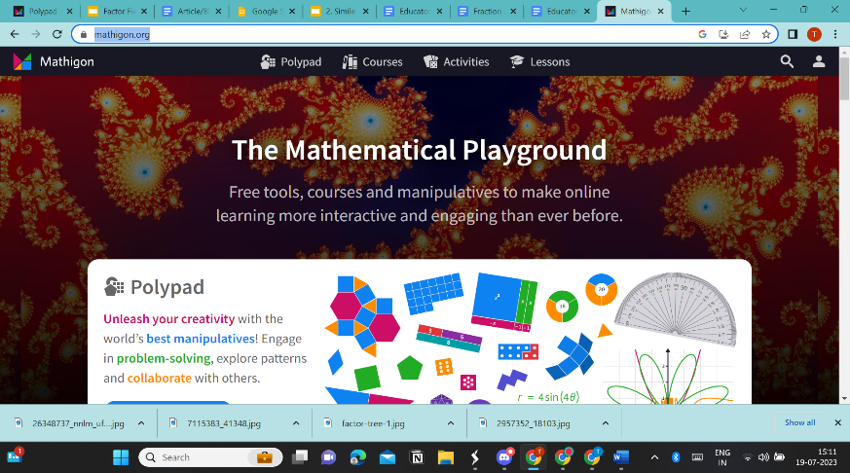

**Creating an Account**

1. Once you have opened Mathigon on your browser, it is recommended that you create an account to save your files. However, you can even proceed without creating an account.
2. On the top right corner of your screen, you will see 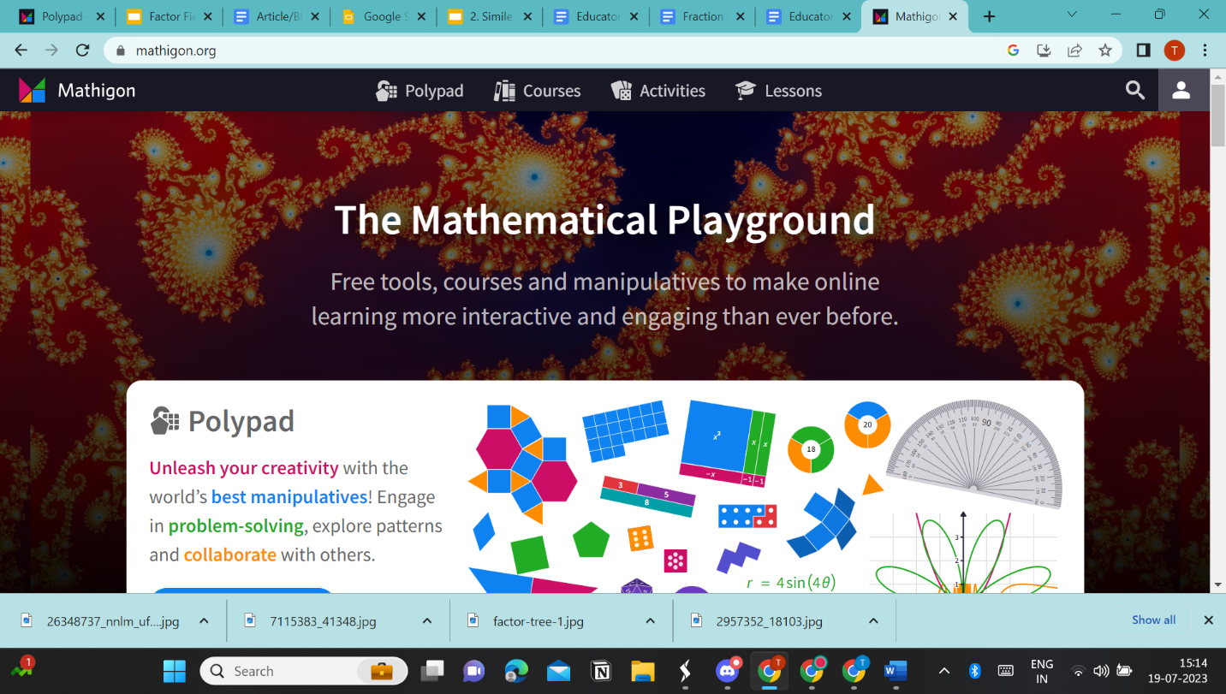. Click on the icon to create a new account.
3. Mathigon offers you the option to create an account as a teacher, student, and parent. It can also be integrated with Google Classroom. Based on what your role is, click on the appropriate option. A student can also join with a class code provided by a teacher.
4. Choose whether you wish to sign in with Google, Microsoft, or by entering your email and creating a password.

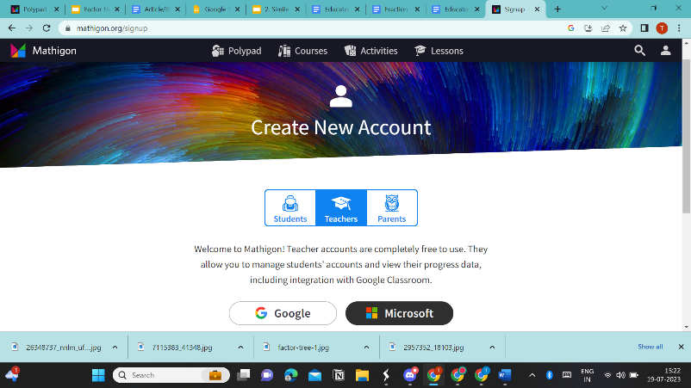

1. Enter your credentials.
2. After entering your details, click on ‘create my account’.

**Navigating User Interface**

**Creating a Classroom**

1. Once you log in, a default classroom will be created for you. If you want another to create another classroom, you can click on ‘create new class’.

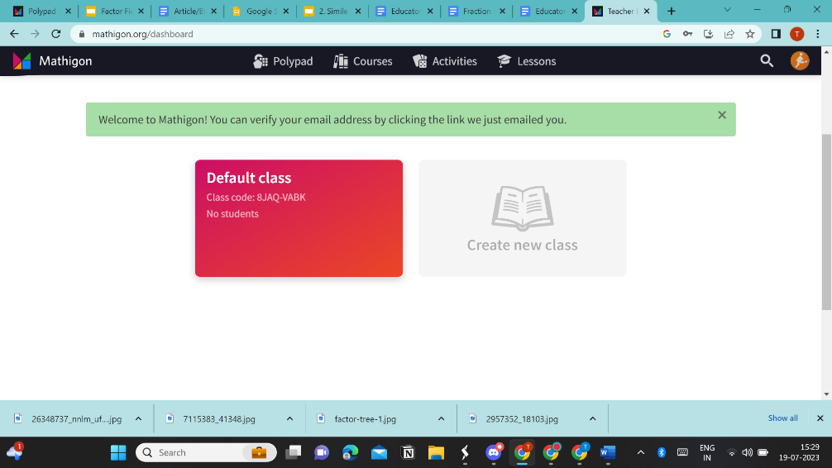

1. Enter a name for the class and click on create.

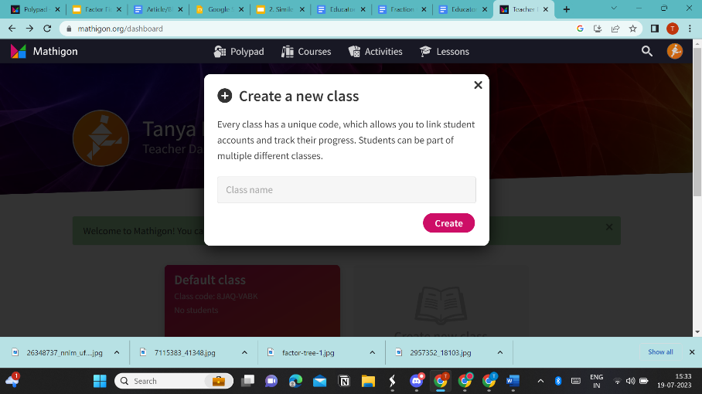

**Adding Students**

1. Students can join your class if you provide them with the class-code, which will be available at the right of the screen.
2. You can also import students from a previously created Google Classroom. You can also add co-teachers, who can have access to all the data within the class.

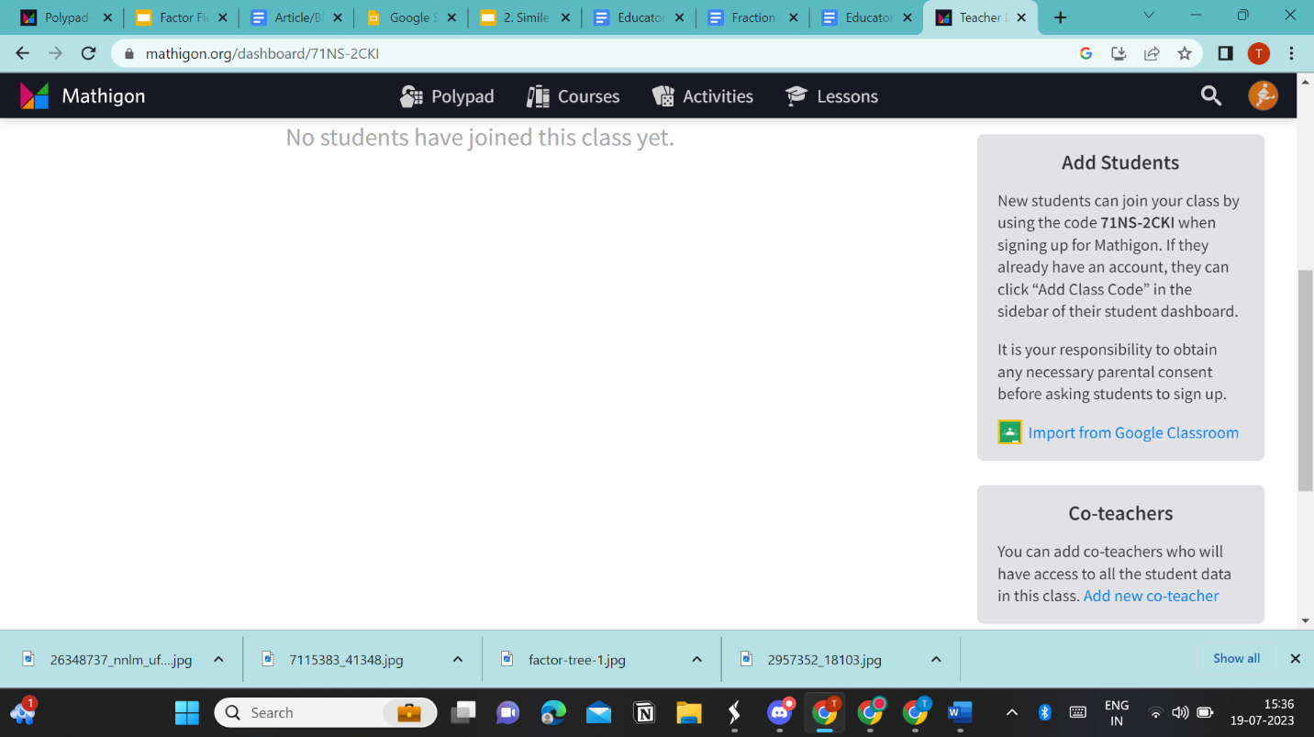

**Using PolyPad**

1. PolyPad is the feature of Mathigon, which offers virtual manipulatives. Click on 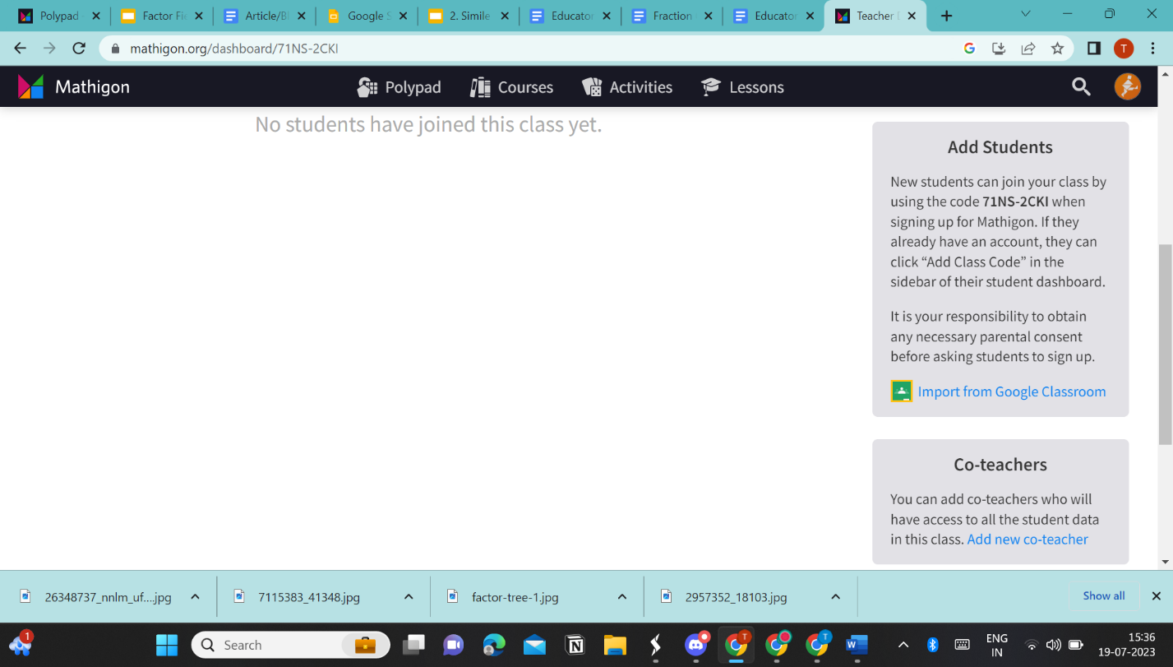 at the top of your screen.
2. To explore the virtual manipulatives, click on 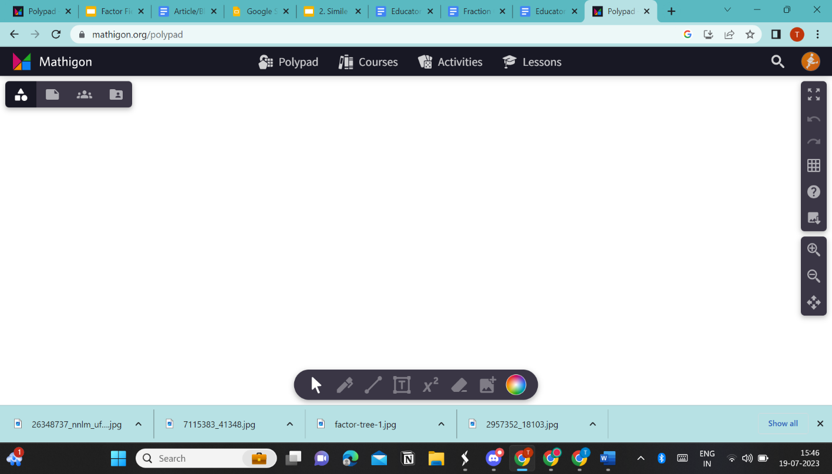 at the left of your screen. You will be able to see the list of tiles. Click on any one to explore its virtual manipulatives.
3. For the Factor Fiesta Activity, click on the ‘numbers’ tile. It will display a list of virtual manipulatives, click on ‘prime factor circles’ to proceed.

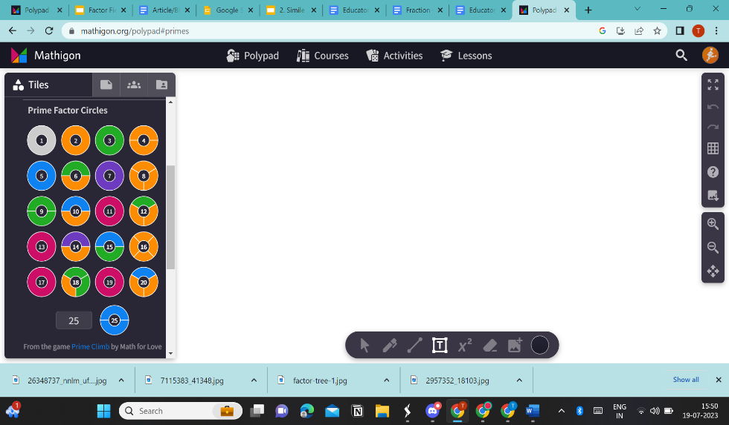

1. Drag any of the prime factor circle to the whiteboard to use it.
2. For example, if you drag the number 16, click on it to drag and split. You will be able to see its factors.

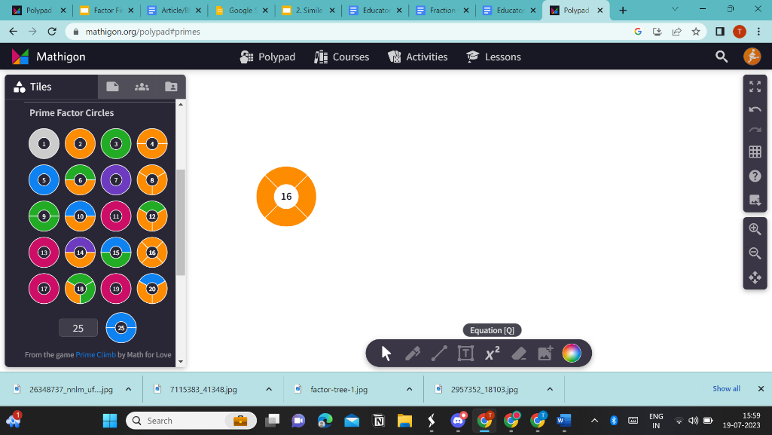

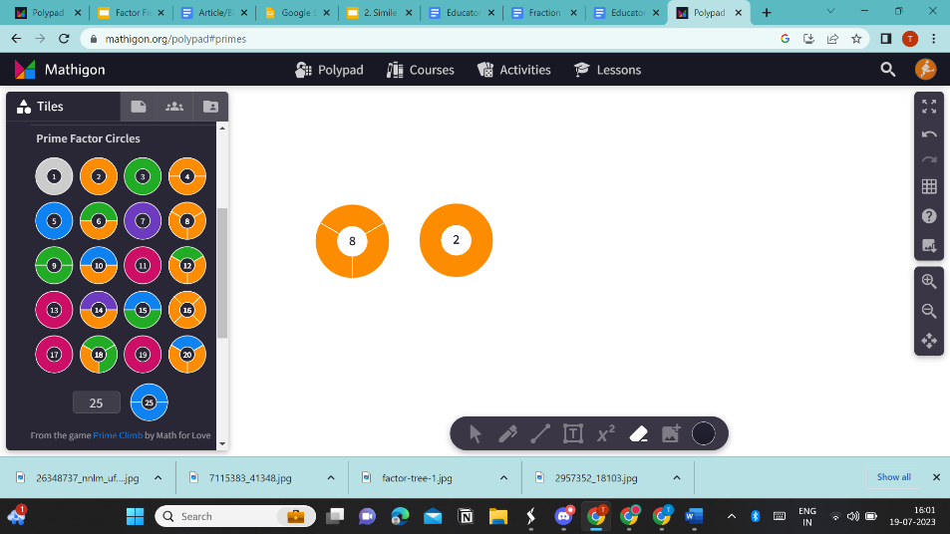

1. Now, split the number ‘8’ further to identify more factors. You will see that the number ‘8’ will split further into 4 and 2. Now, you know the three factors of 16 other than 1 and 16 are 2,4, and 8.
2. You can repeat the process with more numbers to ensure that your learners understand the activity.

**Saving and Assigning the PolyPad**

1. To save the PolyPad, on the left of your screen, click on 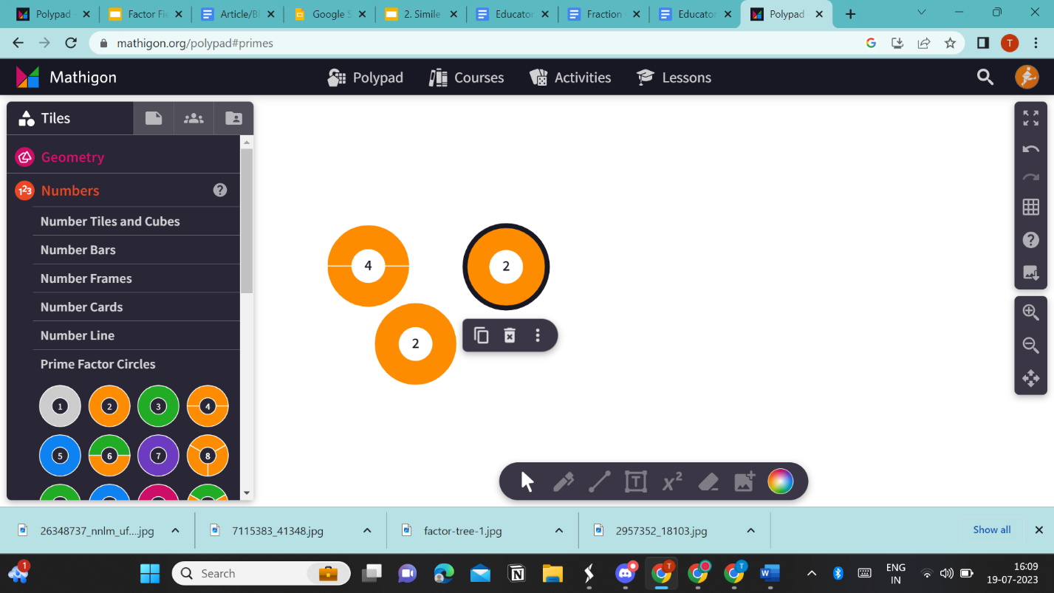. Name your PolyPad and click on ‘save’. You can also change the settings for your PolyPad and share it using the link, which will be automatically generated once you save the PolyPad.

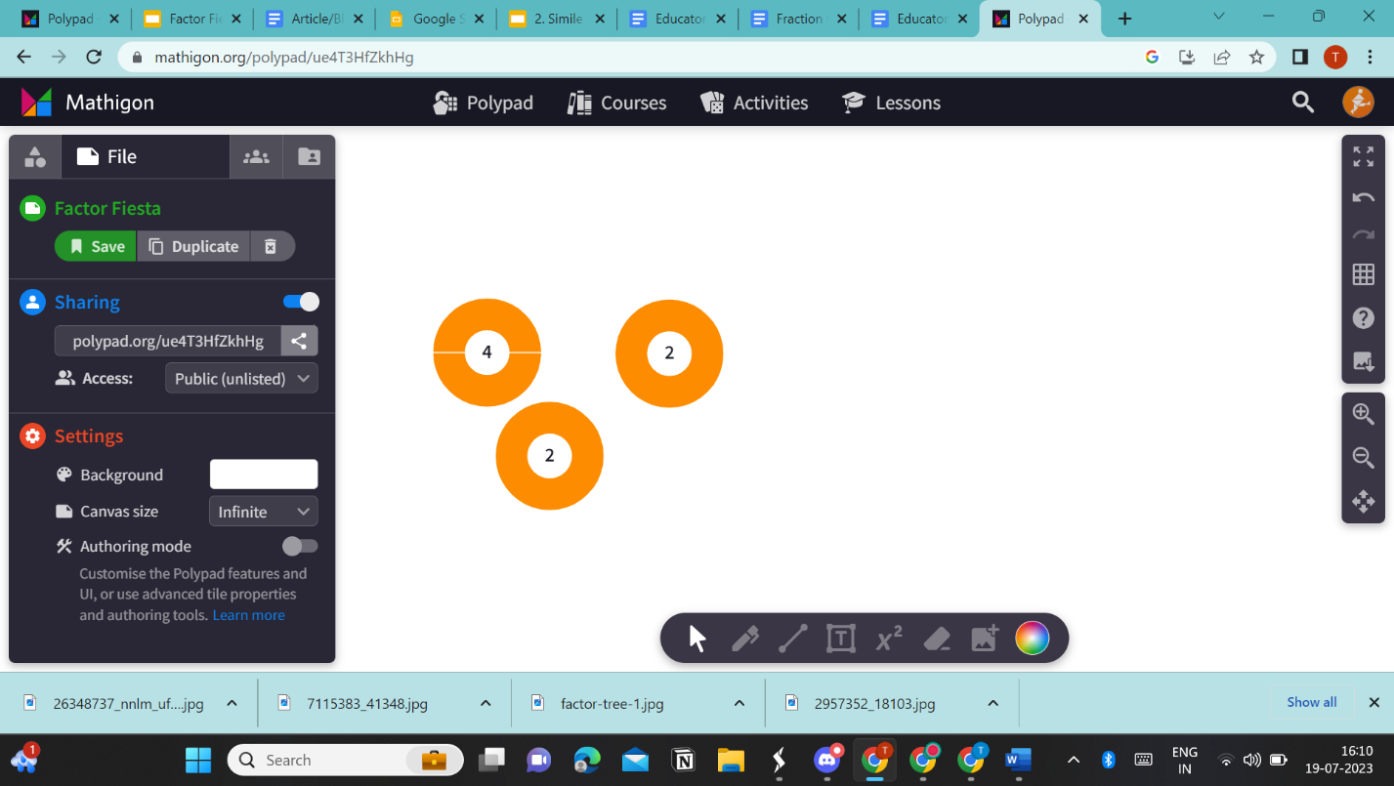

1. Once you save the PolyPad, click on 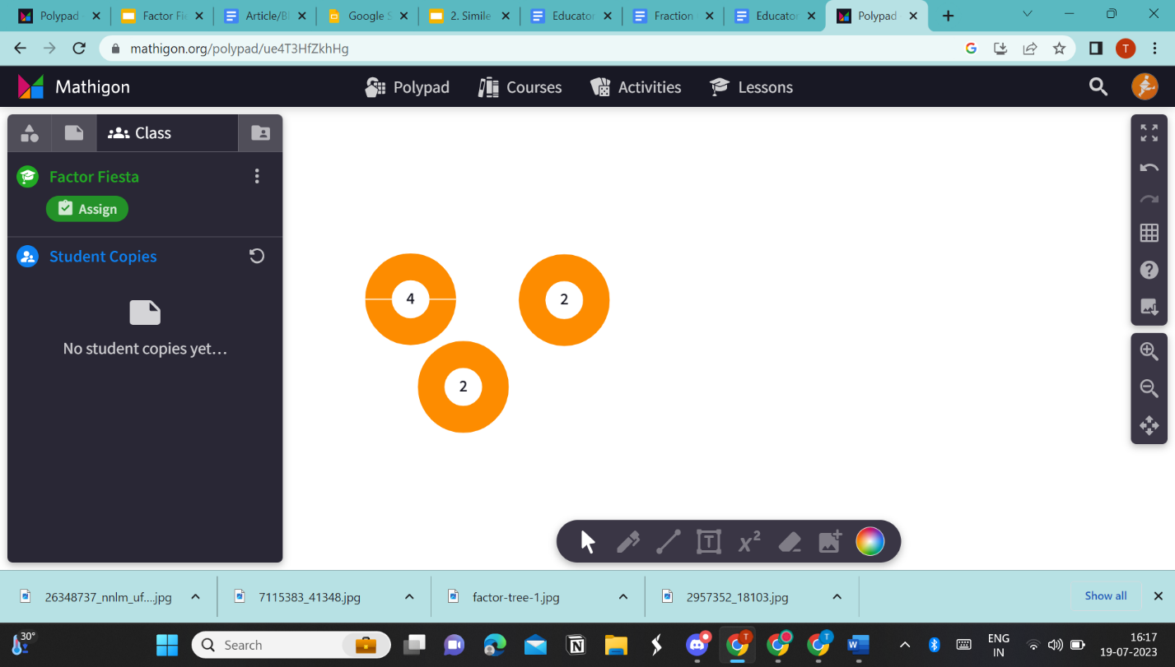 to assign the PolyPad. Click on ‘assign’, which will assign the PolyPad to the classroom.
2. You can also view the students’ copies of the PolyPad using the same setting.
3. You can use the toolbar at the bottom of the screen to erase, draw lines, use the pen, and add texts.
4. You can use the toolbar at the right of the screen to zoom in, zoom out, undo, redo, change the grid display, and get a full screen view.
5. From the ‘tiles’ section at the left of your screen, you can access other virtual manipulatives for other mathematical concepts, such as geometry, numbers, fractions, algebra, and statistics.

**Other Features by Mathigon**

1. To access games based on mathematical concepts, click on 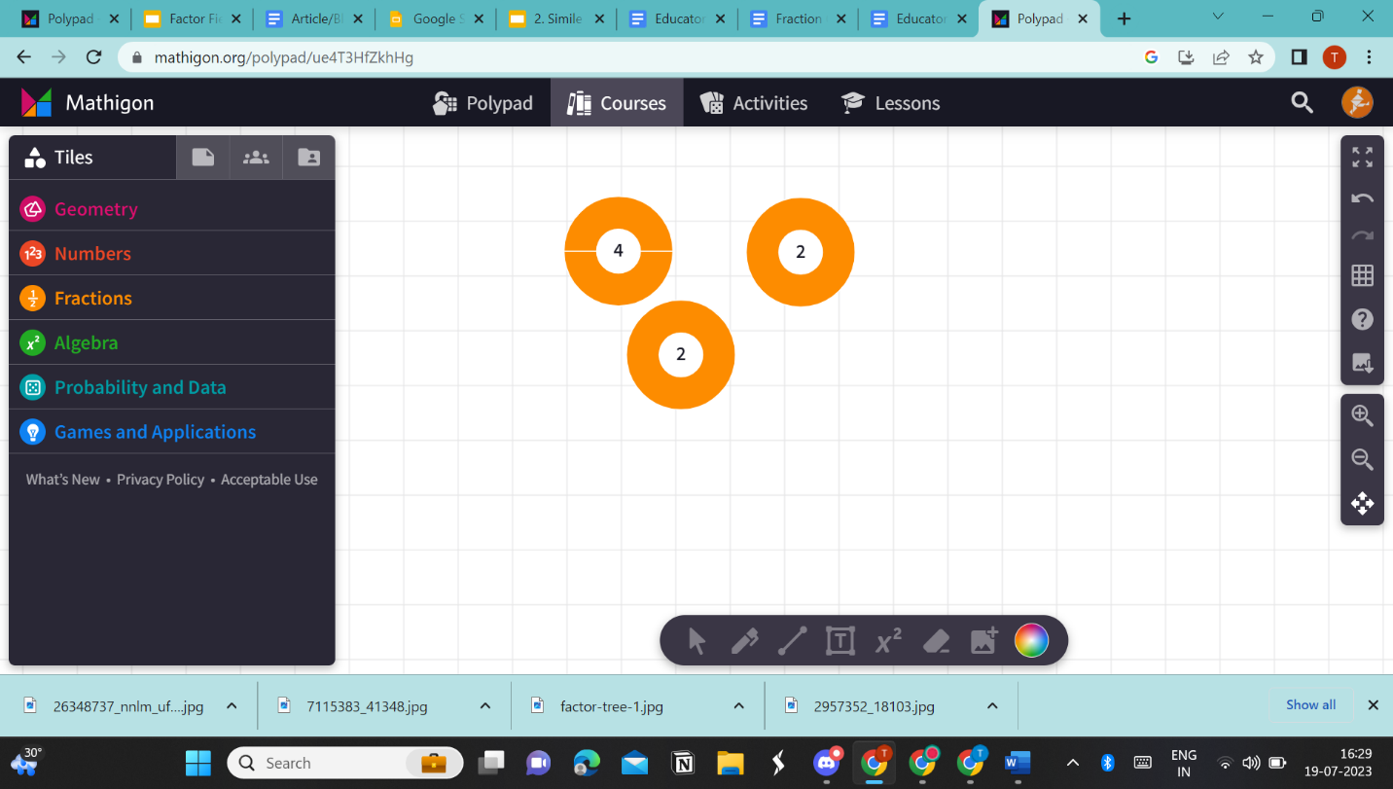 at the top of the screen.
2. Based on the learning objectives, you can choose and play any game available.

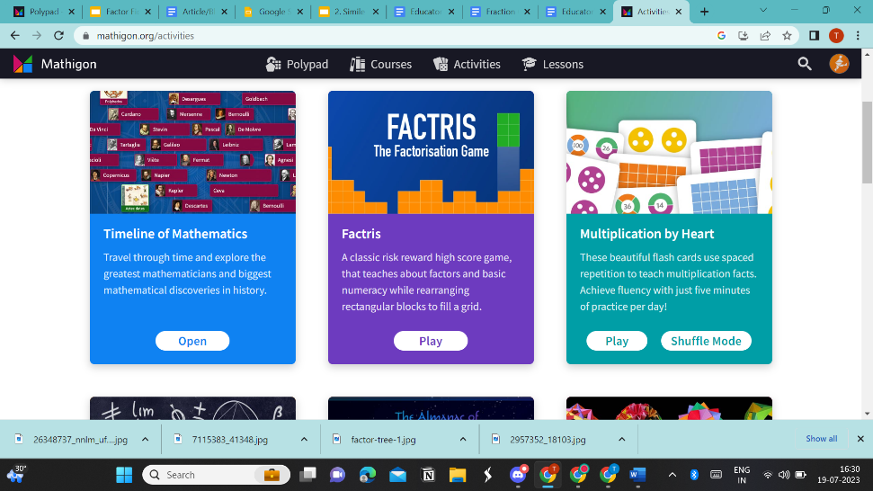

1. You can also access pre-designed lessons and courses available on Mathigon.

If you have more questions about PolyPad, you can access [Frequently Asked Questions](https://mathigon.org/faqs).