**Note:** Shared below are options for different 35 minute activities to get learners started on the journey of fractions. Based on classroom dynamics, choose an activity appropriate for learners:

**Opening Activity Option 1 (Fraction Coloring):** For this activity, you will need printouts of the [fraction sketch template](https://drive.google.com/file/d/1fSRSJareZc5yY4WYLDMFZPtyHH0T_oEc/view?usp=sharing) and some colors. Learners will have to find out equivalent fractions and color them as instructed.

Source: <http://www.kayedstudio.com/>

**Opening Activity Option 2 (Fraction Hopscotch):**For this activity you will need a masking tape and/or chalk. Learners will stand on zero and will throw a rolled up ball of paper. Wherever the ball lands, they then have to read out the fraction and state an equivalent fraction of the same.

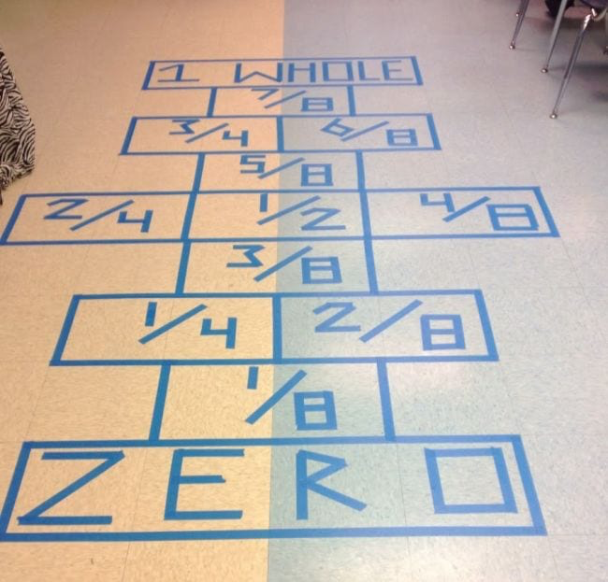

Source: <https://capturing-classroom-ideas.blogspot.com/>

**Opening Activity Option 3 (Fractions about us):** For this activity, you will need white sheets and pencils/pens for each team. Here learners will get to know each other with the help of certain questions and record their answers in the form of fractions. At the end of the activity, they will then introduce the group with the help of fractions.

Learners can choose the questions they want to ask ther peers themselves. Below are some questions for inspiration:

* How many of you take the school bus?
* How many of you had cereal for breakfast today?
* How many of you know how to swim?
* How many of you have a pet?

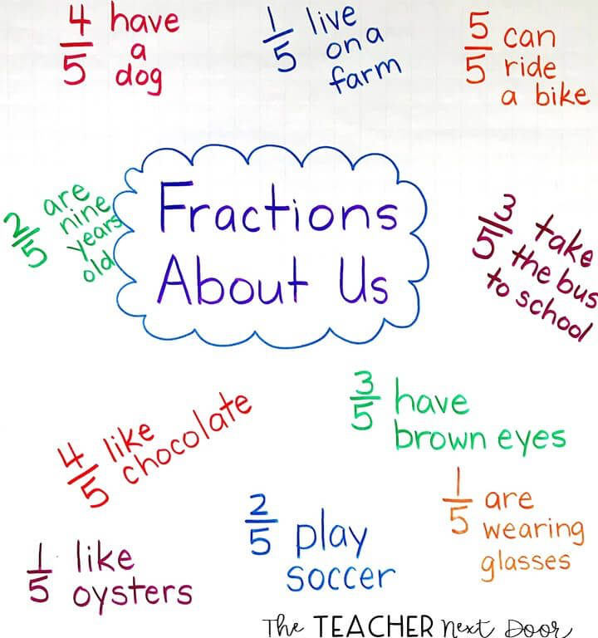

Source: <https://the-teacher-next-door.com/>