**Beginners Guide to Canva**

Introduction

Canva is a user-friendly graphic design tool that allows even those with no design experience to create professional-looking designs. A wide range of templates, tools, and resources makes designing easy, quick, and accessible. Whether you are creating a social media post, a presentation, or a marketing campaign, Canva has everything you need to bring your ideas to life. Get ready to unleash your creativity with this powerful design tool.

Canva is an online tool that requires no download. With its unique collaborative features, your learners can collaborate and work on a project.

Cross Curricular Connection

Canva can be a great tool for building cross-curricular connections between different subject areas. Here are a few ways you could use Canva to build these connections:

* Infographics: Create infographics that showcase data or information related to multiple subjects.

For example, creating an infographic that explores the relationship between climate change and food production, connecting concepts from science and social studies.

* Collaborative Projects: Use Canva to create collaborative projects that involve students from different subject areas working together.

For example, students in a science class could create visual representations of the solar system, while students in an art class create original artwork inspired by the same concepts.

* Posters: Create posters that connect concepts from different subjects.

For example, creating a poster that illustrates the water cycle, while also incorporating relevant vocabulary terms from science and social studies.

* Social Media Graphics: Use Canva to create social media graphics that connect current events and trends to different subjects.

For example,creating graphics that connect social media trends to current events, such as protests or social movements.

By using Canva to create cross-curricular connections, you can help students understand the interconnected nature of different subjects and how they relate to real-world issues and events. This can lead to a deeper understanding of these concepts and an increased appreciation for the importance of interdisciplinary learning.

How to get started?

To get started, simply head over to the link <https://www.canva.com/>.

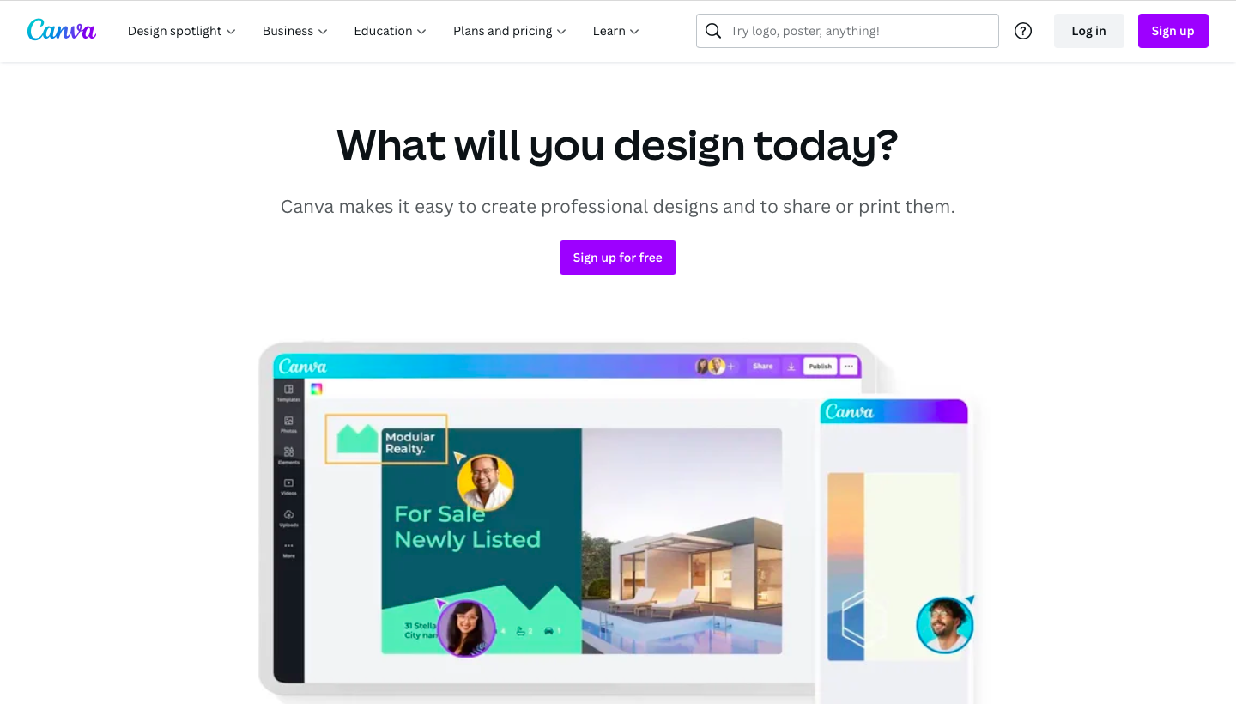

Sign up by clicking on the “Sign up” option as highlighted. You will then be presented with a number of options that you can sign up from. Choose one to proceed.

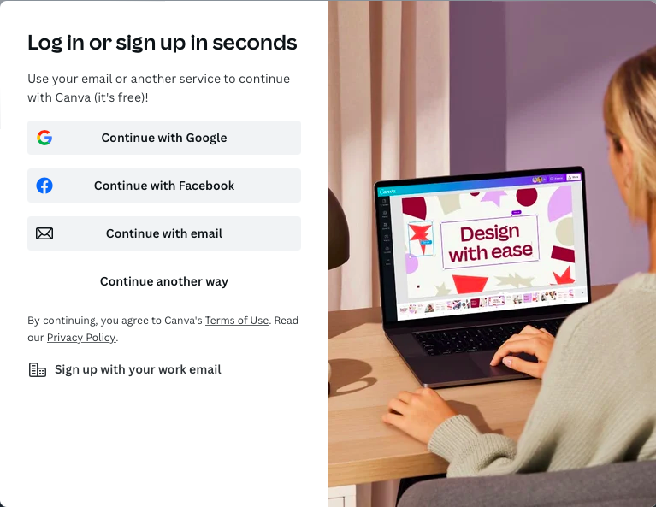

Canva for Education

Canva for Education is designed for K-12 teachers and higher education instructors to help them create engaging and effective visual content for their classrooms.It is a powerful tool that offers the following benefits:

* Easy integration with classroom tools like Google classrooms and other educational platforms.
* Set up a classroom and create and share activities and lessons.
* Choose from a variety of ready to use templates and graphics.
* Collaborate with learners by reviewing and sharing feedback on their work.

**Who can access Canva for Education?**

The use of Canva for Education is free for students and teachers who qualify. It is accessible to everyone worldwide and is not region-specific.

You have to be employed right now in one of the following positions in order to access Canva for Education:

* A licenced K–12 (primary or secondary) teacher who is actively employed as a teacher and attends a school with official accreditation.
* K–12 (primary or secondary) school librarian certified
* A qualified teacher or learning support assistant in grades K–12 (primary or secondary)
* K–12 (primary or secondary) curriculum specialist certified
* a licenced instructor working with elementary, secondary, or vocational students (or any equivalent)
* K–12 (primary or secondary) teachers who are Google Certified Educators (GCEs), Google Certified Trainers (GCTs), or Microsoft Innovative Educators (MIEs)

Canva for Education is also accessible to the government-recognized and formally accredited organisations listed below:

* K–12 (primary, secondary, or pre-college) institutions of learning
* School systems
* Offices of education
* Several international school systems

To learn more about eligibility guidelines visit <https://www.canva.com/education/eligibility-guidelines/>

**How to set up a Canva for Education account?**

Follow the steps below to create your Education account:

1. Visit <https://www.canva.com/education/>.
2. Click “Get verified”.

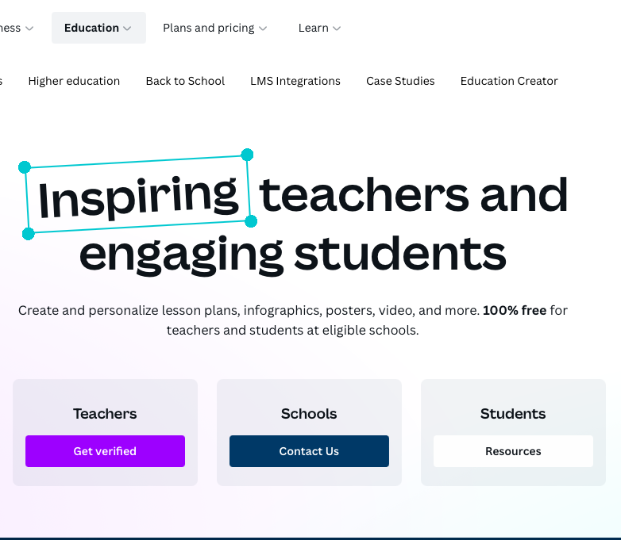

3.) Enter your education credentials to get verified as an educator.

Once you are approved, you will get notified via email.

**How to set up a classroom?**

This [video tutorial](https://www.youtube.com/watch?v=hvlLe81U_pY) will walk you through the steps to set up a classroom. To navigate to a particular section of the video, click on the timestamps below:

* [0:00](https://youtu.be/hvlLe81U_pY?t=0) : Intro
* [0:20](https://youtu.be/hvlLe81U_pY?t=20) : Sign Up
* [0:32](https://youtu.be/hvlLe81U_pY?t=32) : Create a Class
* [0:45](https://youtu.be/hvlLe81U_pY?t=45) : View teams
* [1:20](https://youtu.be/hvlLe81U_pY?t=80) : Add students

This guide will walk you through the steps to create a presentation slide and the different features of the platform you can explore while doing the same.

To create a presentation slide, click “create a design” at the top right corner of your screen once you are in your account and select “presentation” as highlighted. 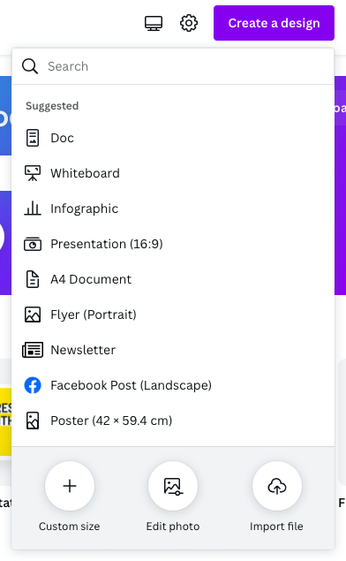

Navigating User Interface

This is what the screen would look like once you have created a presentation design.

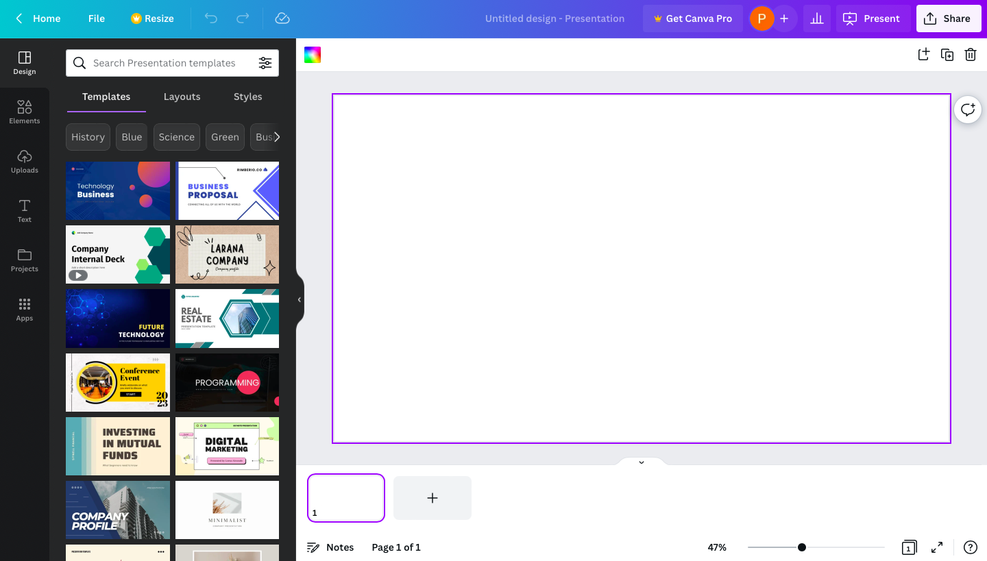

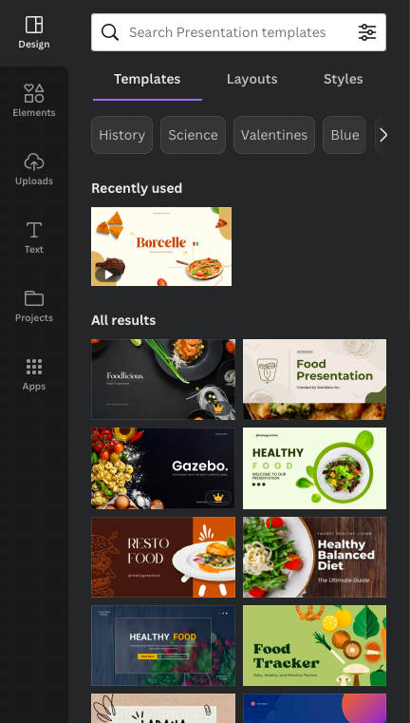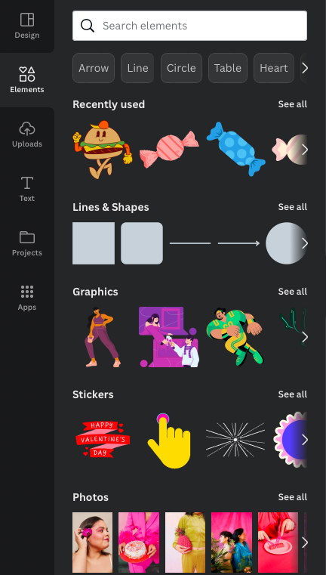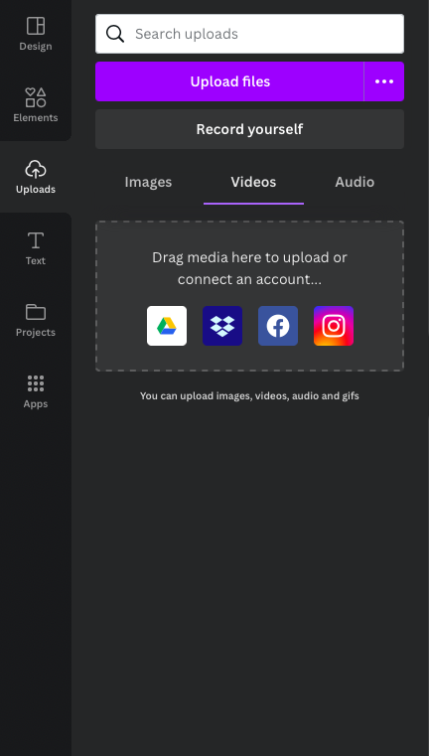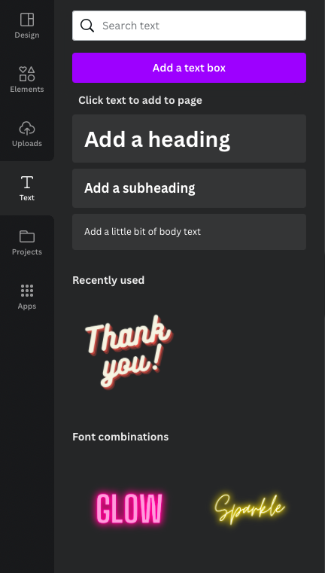

Fig 1 Fig 2 Fig 3 Fig 4

* Fig 1: Head over to the “Design” palette to explore pre built templates. Layouts and styles.
* Fig 2: The elements section allows you to search from a variety of graphics, stickers, photos, videos and audios.
* Fig 3: Uploads section allows you to upload files like images, audio, video etc. You can also record your own audio and video here.
* Fig 4: Text section offers a wide variety of fonts and styles to choose from and add text to your work that stands out.

**Add and customise text**

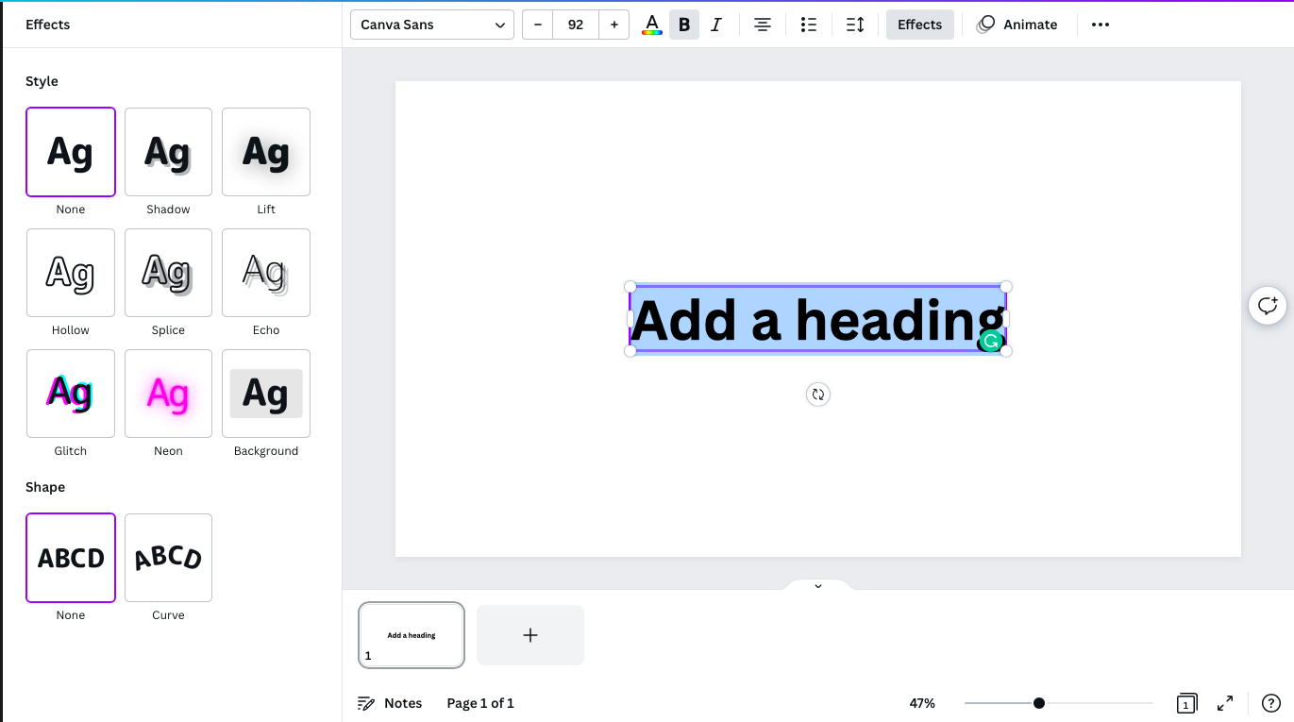

You can choose from available fonts or create and customise your own.

To know more about Canva presentations,visit <https://www.canva.com/presentations/>.

Basic Features

Here are some basic features of Canva:

* Templates: Canva offers a large collection of templates for a variety of design types, including social media graphics, presentations, posters, invitations, and more.
* Customizable design elements: Users can add or edit elements such as text, images, illustrations, icons, shapes, lines, and charts to create unique designs.
* Stock photos and graphics: Canva provides access to millions of stock photos, graphics, and illustrations that can be used in designs.
* Drag-and-drop interface: Canva's intuitive drag-and-drop interface allows users to easily move design elements around the canvas and adjust their size and position.
* Collaboration tools: Canva allows users to invite others to collaborate on designs, making it easy to work on projects as a team.
* Branding tools: Canva offers tools to help users create and maintain consistent branding across designs, including the ability to save brand colors, logos, and fonts.
* Publishing options: Users can download designs as image files or PDFs, share designs directly to social media or email, or print designs.
* Mobile app: Canva also offers a mobile app that allows users to create and edit designs on the go.

Additionally, you can watch this [video tutorial](https://www.youtube.com/watch?v=zJSgUx5K6V0) to explore the basic features of Canva. To navigate to a particular section of the video, click on the timestamps below:

* [0:00](https://www.youtube.com/watch?v=zJSgUx5K6V0) - Intro
* [0:51](https://youtu.be/zJSgUx5K6V0?t=0) - Getting Started
* [2:12](https://youtu.be/zJSgUx5K6V0?t=132) - Editing Images
* [6:15](https://youtu.be/zJSgUx5K6V0?t=375) - Adding text
* [8:30](https://youtu.be/zJSgUx5K6V0?t=510) - Adding Icons
* [10:16](https://youtu.be/zJSgUx5K6V0?t=616) - Outro

Helpful Keyboard shortcuts

Canva offers a variety of keyboard shortcuts to help you work more efficiently. Here are some of the most commonly used shortcuts:

* Undo: Ctrl + Z
* Redo: Ctrl + Y
* Copy: Ctrl + C
* Paste: Ctrl + V
* Cut: Ctrl + X
* Group elements: Ctrl + G
* Align elements: Ctrl + Shift + [left, right, top, bottom]
* Duplicate elements: Ctrl + D
* Delete elements: Delete or Backspace
* Zoom in/out: Ctrl + +/-

Note: Mac users can use Cmd instead of Ctrl.

These keyboard shortcuts can help you save time and increase your productivity when using Canva. Try them out and see how they can improve your workflow.

You can also visit [this page](https://www.canva.com/en_in/help/keyboard-shortcuts/), to browse through all keyboard shortcuts on Canva

Troubleshooting

Canva is a powerful design tool, but like any software, it can sometimes experience issues. If you're facing a problem with Canva, don't worry. This troubleshooting tips section is here to help. We've gathered some of the most common issues that Canva users face and provided solutions to help you resolve them quickly and easily.So, if you're facing any challenges with Canva, read on for helpful tips and solutions.

* Slow loading times: Clear your browser's cache and cookies or try using a different browser.
* Missing elements or fonts: Check your internet connection or try refreshing the page. If the issue persists, log out and log back in.
* Incorrect image resolution: Ensure that the image you're uploading is within Canva's recommended size and resolution. If not, try resizing it before uploading.
* Design elements not aligning correctly: Try using the align and distribute tools to ensure that your elements are correctly aligned. If this doesn't work, try ungrouping and regrouping your elements.
* Difficulty selecting elements: Make sure that you're clicking directly on the element and not on any empty spaces around it. If this doesn't work, try zoom in on the design.
* Error messages: If you receive an error message, try refreshing the page or logging out and logging back in. If the issue persists, reach out to [Canva's support team](https://www.canva.com/help/) for further assistance.

These tips should help you troubleshoot common issues with Canva. If you're still experiencing problems, don't hesitate to reach out to [Canva's support team](https://www.canva.com/help/) for additional assistance.

Next Steps

Here are a few video tutorials that may be helpful as you start using Canva in your classroom:

* [Teach with Canva](https://www.canva.com/designschool/tutorials/canva-for-teachers/) - This playlist will share insights on how to teach and engage your learners using Canva.
* [Getting Started with Canva](https://www.youtube.com/playlist?list=PLATYfhN6gQz8GiTG_nUxVar8ycrt9hJxL) -This playlist is an introduction to Canva and covers the basics of using the platform. Topics covered include creating an account, finding templates, using the design elements and tools, and exporting your designs.
* [How to use Templates in Canva](https://www.youtube.com/watch?v=g7fmkpXZqzY) -This video focuses specifically on using templates in Canva. Topics covered include how to find templates, how to customize them, and how to use them to create your own designs.
* [Canva for Educators](https://www.youtube.com/playlist?list=PLATYfhN6gQz_xQMZOkVYm_UYIHCPtilyj) -This playlist is a compilation of videos covering how Canva can be used in the classroom. Topics covered include how to use Canva to create posters, infographics, and presentations, as well as how to incorporate Canva into your lessons to make them more engaging for your students.

These videos will give you a good starting point for incorporating Canva into your classroom. As you become more comfortable with the platform, you can start exploring more advanced features and functions.