Name: _______________

**Bowling with Friction**

Observe and analyze the different boxes as they slide down the inclined plane.

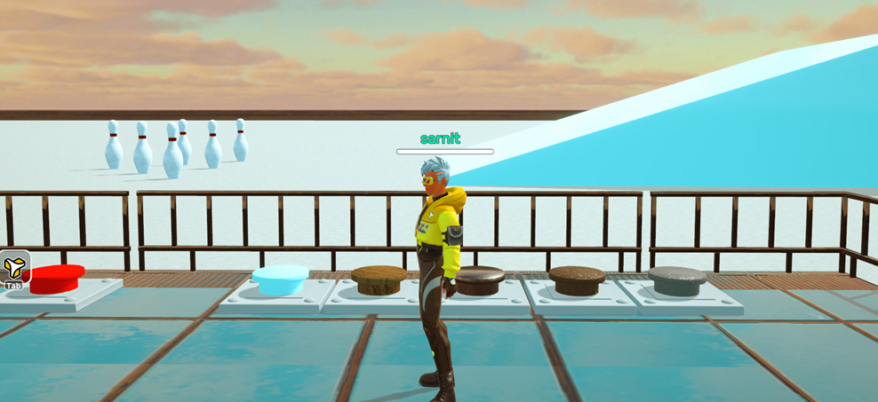

A

C

B

D

E

Bowling pins

Inclined plane

*Note: Five buttons drop a box of different materials onto the inclined plane.*

As your teacher plays the game, fill in the table below with your observations.

|  |  |  |  |
| --- | --- | --- | --- |
| **Material** | **Distance Traveled**  **(Short, medium or long?)** | **Speed while sliding down the plane**  **(Slow, moderate or fast?)** | **Did the box hit the pins?**  **(Yes or no?)** |
| Material A | Long | Fast | Yes |
| Material B | Medium | Moderate | No |
| Material C | Medium | Moderate | Yes |
| Material D | Medium | Slow | No |
| Material E | Short | Slow | No |

**Answer the following questions based on your responses on the table above.**

1. Rank the materials in order of increasing roughness based on your observations.

|  |
| --- |
| E, B, D, B, A |

1. What conclusion can be drawn regarding the impact of surface roughness on the frictional force?

|  |
| --- |
| Different surface roughness can impact the frictional force between objects. The smoother the surface roughness, the lesser the friction between objects. |