Introduction to Genially

Genially is an innovative educational tool that brings learning to life with interactive presentations, infographics, and visual storytelling. While it enables educators to create engaging content, it also empowers learners to create interactive and visually appealing projects. With its user-friendly interface and versatile features, genially transforms classrooms into dynamic and immersive learning environments.

Why Genially?

- Creative Expression – With its wide range of templates, animations, and multimedia options, genially empowers educators and learners to express their ideas creatively, fostering a sense of ownership as well.
- Interactive Learning – By incorporating interactive elements like quizzes and videos, genially turns static content into dynamic learning experiences, enhancing learners’ understanding and retention of information.
- Digital Storytelling – Learners can use genially to craft compelling digital stories, improving their storytelling skills and enhancing their ability to communicate effectively with multimedia elements.
- Collaborative Projects – Genially’s collaboration features enable learners to work together on group projects, promoting teamwork and communication skills.
- Multidisciplinary Application – Genially is suitable for various subjects and disciplines, from creating science infographics to history timelines, allowing educators and learners to use their creativity across the curriculum.

Access
You can use Genially on any web browser. We recommend the latest Chrome, Mozilla Firefox, and Microsoft Edge (Version 44 and newer) versions for the best performance. Go to https://genial.ly/ to start.

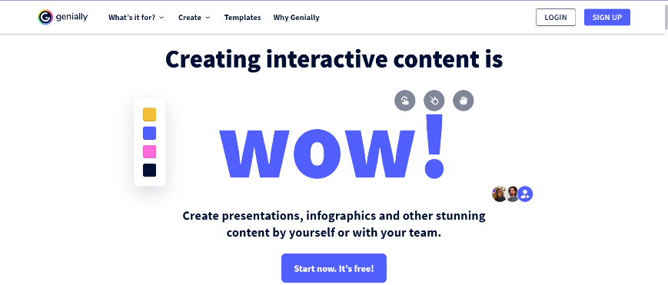

Creating an Account
- Once you have opened Genially on your browser, to create an interactive presentation, it will require you to sign up.
- On the top right corner of your screen, you will see the ‘sign up’ option on your screen, as shown in the image attached above. Once you click on it, it will provide you with the option to sign up with google or use your email.
- Enter your credentials. After entering your details, click on ‘create my account’.
- To further personalize your experience, you will be asked whether you want to use Genially for educational purposes or corporate purposes. Depending upon your intent, choose the appropriate option.
- If you click on education, it will ask you whether you are a student or a teacher, click on the appropriate option to continue. It will ask you a few more questions, choose the appropriate responses. Click on ‘Go to my Panel’ to continue.

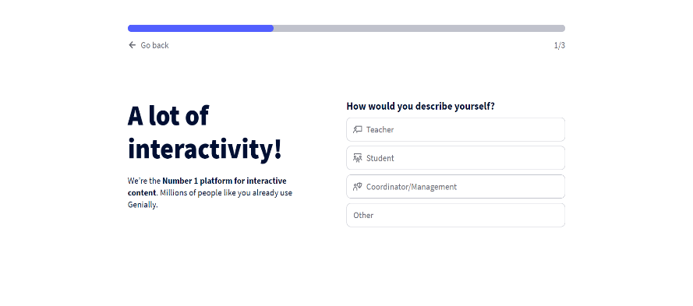

Navigating User Interface

Choosing a Template

- Once you have access to the panel, you will notice that you can choose what you wish to create. Genially offers the choice to create interactive presentations, infographics, images, videos, and guides.

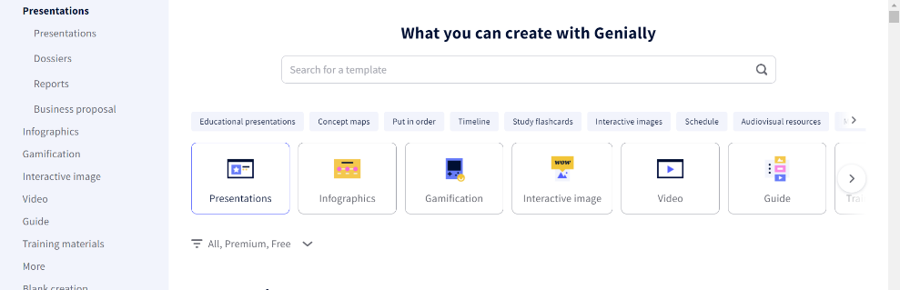

- Based on what you choose, genially offers multiple templates, which you can modify. It also offers you the opportunity to start from scratch by choosing a blank template. Click on your preferred template and click on ‘use this template’ to continue.

Adding Elements to your Presentation

- To add a page to your presentation, click on at the bottom of your screen. For each page, you will receive multiple templates and you can choose accordingly.
- To add text to your page, click on ‘text’, which is available at the toolbar on the left of your screen. You will see multiple text templates on your screen. Click on the option that seems suitable to you.

- Similarly, you can choose images, resources (icons, shapes, arrows, illustrations, interactive graphs), interactive elements (buttons, interactive questions), smart blocks (diagrams, data tables, maps).
- You can also insert audio, videos, and images by uploading them from your device or by pasting the URL. You can also record an audio.

- To make your presentation interactive, you can animate your images/GIFs/texts.
- Simply click on the element you wish to animate and click on , which will appear above the element once you click on it. It will offer you multiple animation effects and you can choose any one that you like.
- Similarly, to make an element interactive, such as adding a tooltip letting the element redirect you to another page, reveal a text, or play music when you click on the element, choose , which will appear above the element once you click on it. You can choose the interactivity option, which is suitable for your presentation.
- You can refer to this presentation to understand how elements can be made interactive. Click on the image/GIF to see the use of the reveal interactive element.

Presenting and Sharing your Genially Creation

- To add collaborators to your creation, click on , which is available at the top of your screen. Write the emails of people you wish to add to your creation and you are all set!
- To share your presentation with your colleagues/learners, click on , which is available at the top right corner of your screen. You can also rename your creation and add a description to it.

If you need more help on how to use genially and its features, click on genially support.

