Introduction to PictoBlox

For an unparalleled blend of captivating learning experiences and the dynamic integration of hands-on technology, PictoBlox emerges as an indispensable tool that demands your exploration.

PictoBlox, a product by STEMpedia empowers learners with comprehensive tech education and unlocks their potential to turn ideas into tangible reality with an extensive range of tools, including coding, artificial intelligence, machine learning, game design, virtual reality, natural language processing, and more.

This guide will help you understand how to download the software, set up a PictoBlox account, and navigate its interface, and its features.

Creating cross-curriculum connections

While PictoBlox is a visual programming software designed primarily to introduce learners to the world of programming and robotics, it can be used to create multiple cross curricular connections. Here are some examples:
- Language Arts: PictoBlox can be used to enhance language skills by creating interactive stories or animations. Learners can create characters, develop dialogues, and program their interactions.
- Social Science: PictoBlox can be used to recreate historical events. Learners can program animations or simulations to understand historical timelines, explore cultural practices, or visualize geographical concepts.
- Mathematics: PictoBlox offers various mathematical operations and functions, allowing learners to practice mathematical concepts while programming.
Access
You can use PictoBlox on any web browser. Go to https://pictoblox.ai/ to start. We recommend the latest Chrome, Mozilla Firefox, and Microsoft Edge (Version 44 and newer) versions for the best performance. However, to explore some of its features and extensions, such as Machine Learning, you have to download the PictoBlox software. It is recommended that you download the software to access all the features that PictoBlox offers.

Downloading the PictoBlox Software

- Go to https://thestempedia.com/product/pictoblox/download-pictoblox/
- Choose your device (windows/macOS/Linux/Android/iOS/Chromebook
- Based on the device that you choose, you will see a button, which allows you to download the software.
- Click on the button to continue.

- Once you click on the button, you can enter your name and email if you would like to receive more updates about PictoBlox. However, you can also proceed without entering your details by clicking on ‘Download Now’.
- After you click on the button, it may take 7 to 10 minutes to download the software.
- After successfully downloading PictoBlox, a window will appear on your screen, click on ‘install’ to continue.
- Further, click on ‘finish’ to complete setting up PictoBlox.

Creating an Account
- Once you are done setting up PictoBlox on your device, it is recommended that you create an account to save your files. However, you can even proceed without creating an account.
- On the top right corner of your screen, you will see an option to sign in.
- Since this might be your first time using PictoBlox, click on ‘register’ to create an account.
- Based on whether you are a student or teacher, you will be asked to enter your details.
- After entering your details, click on ‘create my account’.

Navigating User Interface

Adding Extensions

- PictoBlox offers a variety of features. You can explore each feature at your own pace. To access and explore these features, you might have to use extensions.
- At the bottom left of your screen you will find . The icon will help you add extensions to your PictoBlox. Once you click on the icon, you will be redirected to choose an extension based on what you want to work with. Once you choose, the extension will be added to your PictoBlox interface.
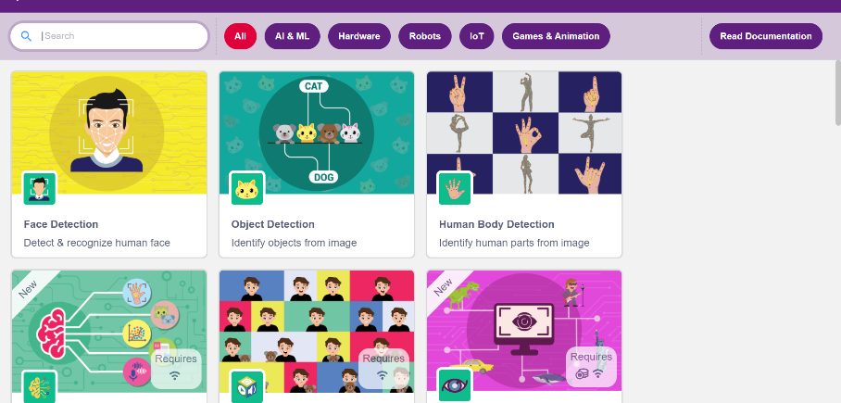

Choosing a Sprite

To make PictoBlox more interactive and engaging, you can choose a Sprite. In PictoBlox, a Sprite is a graphical character or object that can be programmed or manipulated within the environment.
      - To change your sprite, click on at the bottom right.
      - Once you click on the icon, you will be redirected to a window, which will have multiple Sprite options.
      - Based on your preference, you can choose a character or an object.
      - You can also add multiple Sprites to your interface.

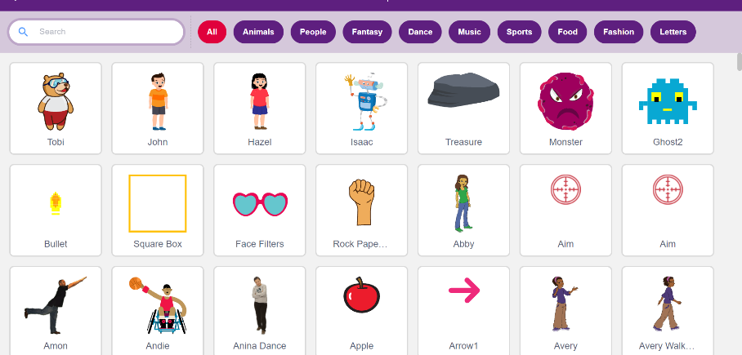

Choosing a Backdrop

Just like you can choose a Sprite, you can choose a backdrop to make the experience of using PictoBlox fun and engaging.

            - To choose a backdrop, click on at the bottom right of your screen.
            - Once you click on the icon, you will be redirected to a window with multiple backdrop options.
            - Based on your preference or the theme of the activity, you can choose the appropriate backdrop.

Now that you are aware of some of the basic features of PictoBlox, let us move onto the tutorial for the Eddy activity.

Note: Although the tutorial is activity specific, it will guide you on how to use block coding to create interactive and engaging learning experiences.

Movie Mania with PictoBlox

- Since we are using Natural Language Processing for the Eddy activity, you can click on the icon and type ‘natural language processing’ in the extension search box.
- Once you add the NLP extension, you will notice that it has been added on the left side of your screen.

- After adding the extension, we can change the Sprite and the backdrop as per our activity.
- Since the activity is called ‘Movie Mania’, you can choose a theatre backdrop by clicking at the bottom right of your screen.

Making a Block
Since we will be engaging in block coding, the first step of the process is to make a block. To make a block for Movie Mania, follow the steps:
- Click on which is available on the tool bar at the left of the screen.
- Choose ‘Make a Block’, which will lead to the image as shown below.

- Name your block. In this case, since we are providing a demo for action-packed movies, write ‘Action-packed Movies’ as the name of the block.
- Click on ‘OK’ to continue.
- Once you click on ‘OK’, you will notice that the block will be added to your workspace (where you will be writing the codes).

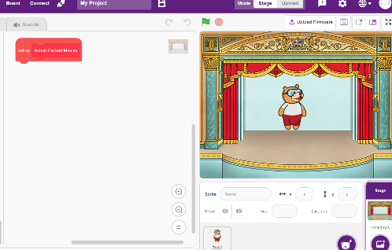

Using the NLP Extension

The next step in the process is to define the block that has been created. To do so, we need to use the Natural Language Processing extension.
- Click on , which is available at the tool bar at the left of the screen.
- Drag the ‘add your text as class’ block to the workspace and place it right below the block named ‘action-packed’ movies.
- Now, replace the first blank, which says ‘your text’ with a mood that you can think of when you wish to watch Action Packed movies. For example, if you feel adventurous while watching action-packed movies. Write adventurous in the first blank and Action- packed Movies in the second blank. Refer to the example shown below.
- Now, right click on the NLP block to duplicate it. Replace ‘adventurous’ with a synonym, such as ‘thrilled’ or any other adjective that describes your mood when you feel like watching action-packed movies.

- Duplicate the block and replace ‘thrilled’ with another adjective that describes your mood when you feel like watching action-packed movies.
- Continue the process at least three to four times as shown in the image below.

- After demonstrating the process of creating blocks and adding classes, encourage them to create blocks for ‘feel good’ movies and ‘science fiction’ movies in the workspace. The idea is to let them think of the adjectives that can describe their moods and correspond to the movie genres.
- Create a new block named ‘training’ as we will be training Tobi to identify the moods and recommend movies.
- Now, add ‘reset text classifier’ to the training block. The purpose of a ‘reset text classifier’ is to erase all the information that the computer must have previously learned in order to feed new information,
- Next, add the data blocks for ‘action-packed’ movies, ‘feel-good’ movies, and ‘science fiction’ movies under the training block.
- Stack them one after the other.
- Further, stack the train text classifier block. Refer to the image below to see what it must look like.
Block Coding
Now that all the blocks have been created using the Natural Language Processing Extension, it is time to write the script that will make Tobi recommend movies based on moods.
- Click on the ‘events’ palette available at the toolbar. Then choose the block with a green flag on it. Drag it to the workspace.
- Go to the ‘My Blocks’ palette and stack the ‘training’ block as shown below.
- Click on the ‘look’ palette and drag the block which says ‘hello’ for 2 seconds.
- Replace it with what you want Tobi to say when it greets you. Change the timing from 2 to 5 or 7 seconds.
- Next, from the ‘sensing’ palette at the toolbar, add an ‘ask and wait’ block. Replace ‘what is your name’ with ‘How do you feel today?’.

- Further, from the ‘control’ palette at the toolbar, drag and stack and ‘if…then’ block below the ‘ask and wait’ block.
- Inside the ‘if’ block, place an ‘=’ to block from the ‘operator’ palette.

- Inside the first space of the ‘=’ block, place ‘get class of’ block from the ‘NLP’ palette. In the second space, write action-packed movies.

- Inside the ‘get class of’ block, drop an answer block from the ‘sensing’ palette.
- Now, inside the ‘if block’, place the ‘think for 2 seconds’ block from the ‘looks’ palette.
- Replace the text with ‘Hmm… You can watch some action-packed movies’ and change the timing from 2 to 7 seconds.
- Now drag a ‘say’ block from the ‘looks’ palette and replace it as shown below.

- Do the same for ‘feel good’ movies and ‘action-packed’ movies by dragging another ‘if’ block and repeating the process.
Note: Refer to the movie list to add movies for the other two categories.
Testing your script
Once you are done writing the script, it is time to test whether Tobi is able to recommend the movies based on moods. To test, follow the steps mentioned below:
- Click on the green flag to run the script.
- Tobi will first welcome you to the virtual theatre, following which, it will ask how you feel.
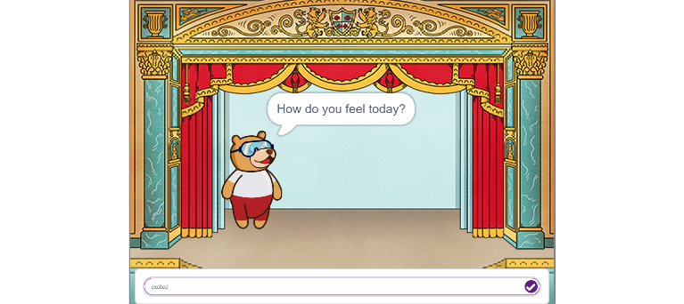
- Enter your response as one of the moods you mentioned. For example, if you mentioned ‘excited’ as one of your moods while writing the script. Write, ‘excited’ in the blank.

- Based on your response, Tobi will recommend you to watch a certain category of movies. For example, if you placed ‘excited’ under the category of action-packed movies, it will recommend you to watch action-packed movies and mention the movies that you wrote in the script.
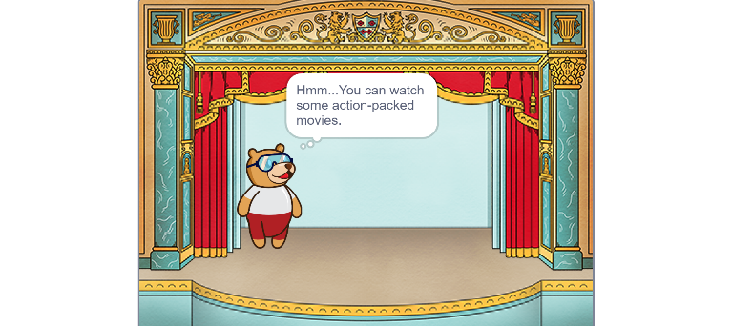

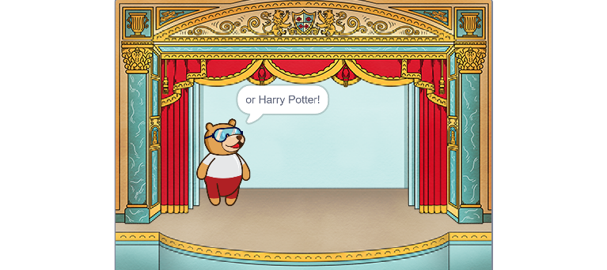

Saving your Work
You can save your script as a scratch file on your computer by following the steps
- Click on file at the top left of your interface.
- Click on ‘save as’ and name your file.
- To reopen the saved file, click on ‘file’ and click on ‘open’.
- Click on ‘Open from Computer’ and find your saved file.
- You can view it and continue working on it.

Troubleshooting Tips

- Check system requirements: Ensure that your computer meets the minimum system requirements to run PictoBlox.
- Update PictoBlox: Make sure you have the latest version of PictoBlox installed.

