Beginners Guide to SimCity

Introduction
SimCity is a management simulation game designed and produced in 1989 by American designer Will Wright and electronic game developer Maxis. SimCity is a pretty original game, and it inspired an array of sequels, including the very successful series The Sims. The map-building functions of other games are encouraged by it, and it is originally known as the game Micropolis. In this game, you can be the hero of your city as you design and create a beautiful, bustling metropolis in SimCity BuildIt. Every decision is yours as your city gets larger and more intricate. Make smart choices to keep your citizens happy. And understand the economy at large.

How to get started?
SimCity makes it simple to visualize your ideas, whether to Build a store or a shopping mall, create attractive residential buildings, Recreate the highways, provide utilities,build roads, rooms in the home, or buildings in the community .
These are some examples of projects that help learners consolidate their learning in one place while also having fun and building digital literacy skills.

To get started, simply head over to the link https://www.ldplayer.net/games/simcity-buildit-on-pc.html#google_vignette and download the Ld player and install the SimCity game.

Tech check
Here’s what’s needed technically to use SimCity.

What is the SimCity BuildIt PC version?
SimCity BuildIt is a Simulation app developed by ELECTRONIC ARTS. After downloading an Android emulator from this page, you can play SimCity BuildIt on a PC.
Android emulators are software that runs a virtual Android device on your computer. LDPlayer is one of these Android emulators for Windows PC.
LDPlayer also provides additional features such as multi-instance, macros, operations recording, etc. Using the Android 9.0 system, LDPlayer can help you play mobile games on PC with faster performance and higher FPS.

Is it possible to play SimCity BuildIt on PC without Android emulator?
If the developer of SimCity BuildIt releases a PC client, you can definitely play it on PC without using an Android emulator. However, you can have a better gaming experience if you play SimCity BuildIt on PC with LDPlayer.
With LDPlayer, you can both play SimCity BuildIt on your big screen monitor with better graphics, and enhance your gaming experience with the follow features:
- Multi-instance Manager: create several emulator instances on one computer and you can play multiple games simultaneously.
- Multi-instance Synchronizer: use one main instance to control all instances and this can help you reroll your games faster.
- Keyboard Mapping: custom your keyboard mapping, or use the official ones to control your games like a pro.
- Macro Recording: record operations for your games and run the script to auto-play some tasks.

Recommended PC Configurations for Playing SimCity BuildIt on PC
The following specifications are recommended for playing one or two instances:
CPU: Intel or AMD Processor like x86 or x86_64
System: Win7 / Win8 / Win8.1 / Win10 / Win11 (Do not support Mac version)
Graphics Driver: Windows DirectX 11 or Graphics driver with OpenGL 2.0
RAM: 16 GB
Disk Space: Minimum 100 GB
VT: Virtualization Technology (Intel VT-x/AMD-V): enabled Simple Steps to enable VT
If you have needs for playing multiple instances, it's recommended to use the CPU with higher numbers of cores and graphics card with higher vram. You can refer to this tutorial How to open as many instances of LDPlayer as possible.

How to Download and Install SimCity BuildIt on PC
Step 1: Download LDPlayer, a free Android emulator to play Mobile games & Apps on PC
Step 2:Complete the installation of LDPlayer on your desktop
Step 3:Launch LDPlayer and search SimCity BuildIt on the search bar
Step 4:Install the game from LD Store (Or Google Play)
Step 5:Once installation completes, click the game icon to start the game
Step 6:Enjoy playing SimCity BuildIt on your PC with LDPlayer

Navigating User Interface
Setting up your account
1. Download Ld player and Install SimCity buildit.
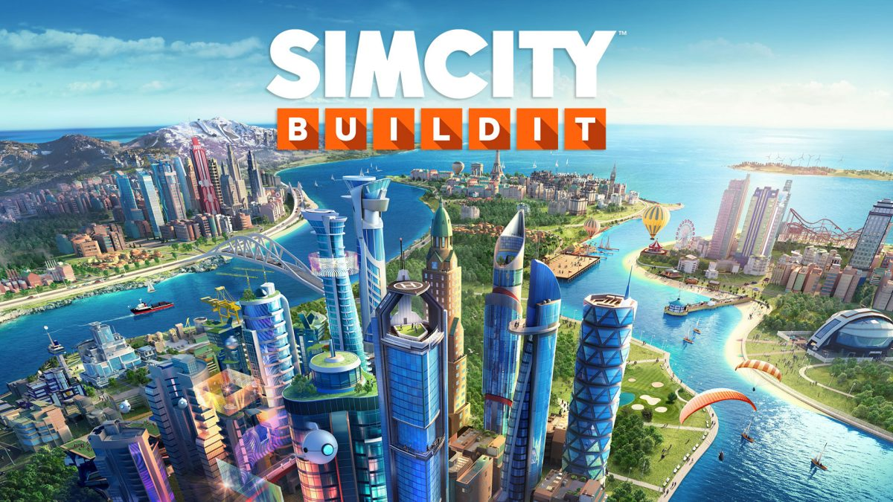
2.Go to the "Settings" menu and select "Rename City". The name of the city will be displayed when advertising products in the main office of the World Trade Operations company and during the visits of your friends.
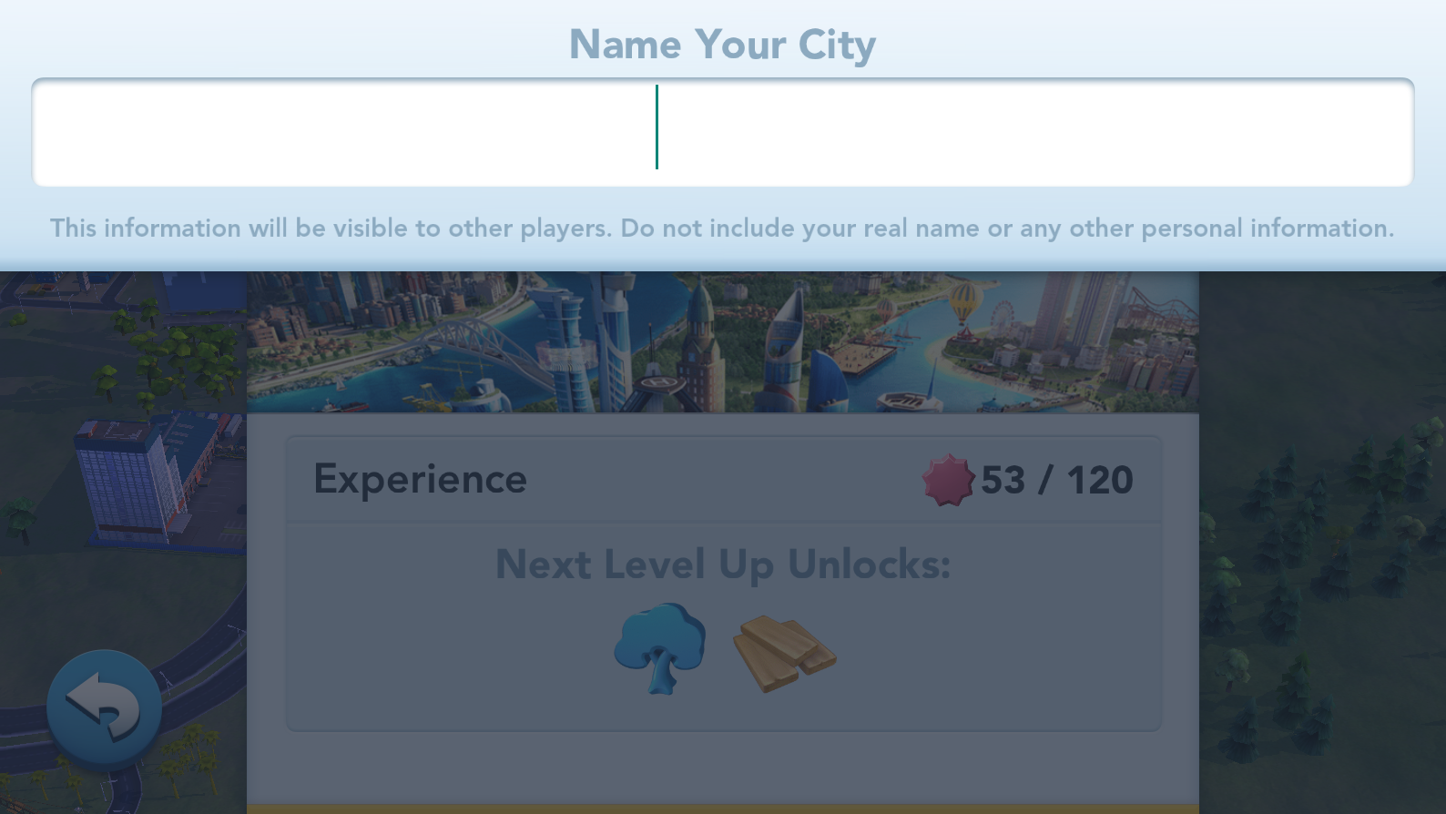

3.Increase the population of your city simply by taking care of your citizen's needs and wants to provide them with Well-off residential areas, parks, education, entertainment, and transport. The construction and modernization of the residential regions increase the base population.
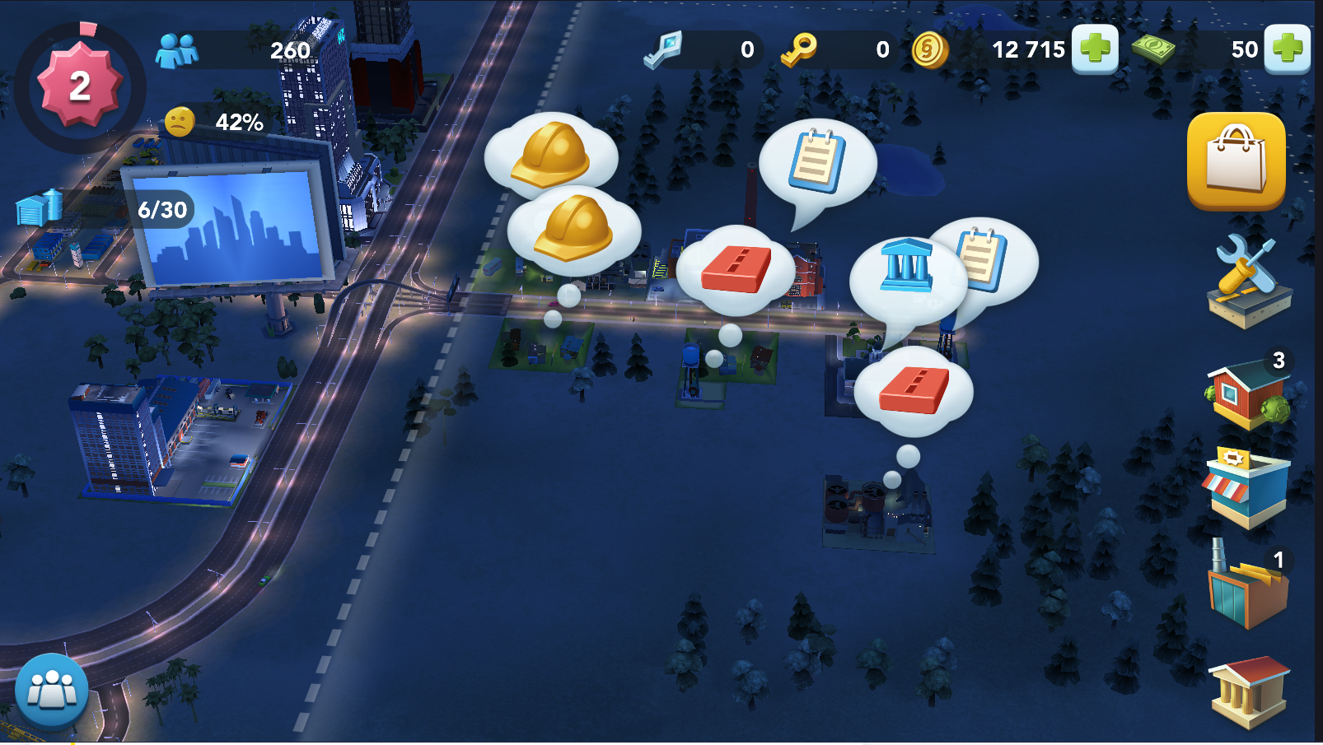
4.Blue columns will appear on the map when solving the problem of where to place specializations. They indicate how many percent the population will increase if you start construction in the place where you hover over, so choose carefully! The population counter is at the top of the screen and displayed as a blue icon depicting people.

5.Unlock more varieties of materials, more production sites, and more efficient plants as you progress in the game. Click on the factories icon on the right of the screen to see a list of factory buildings, including those currently operating in the city and those that can.
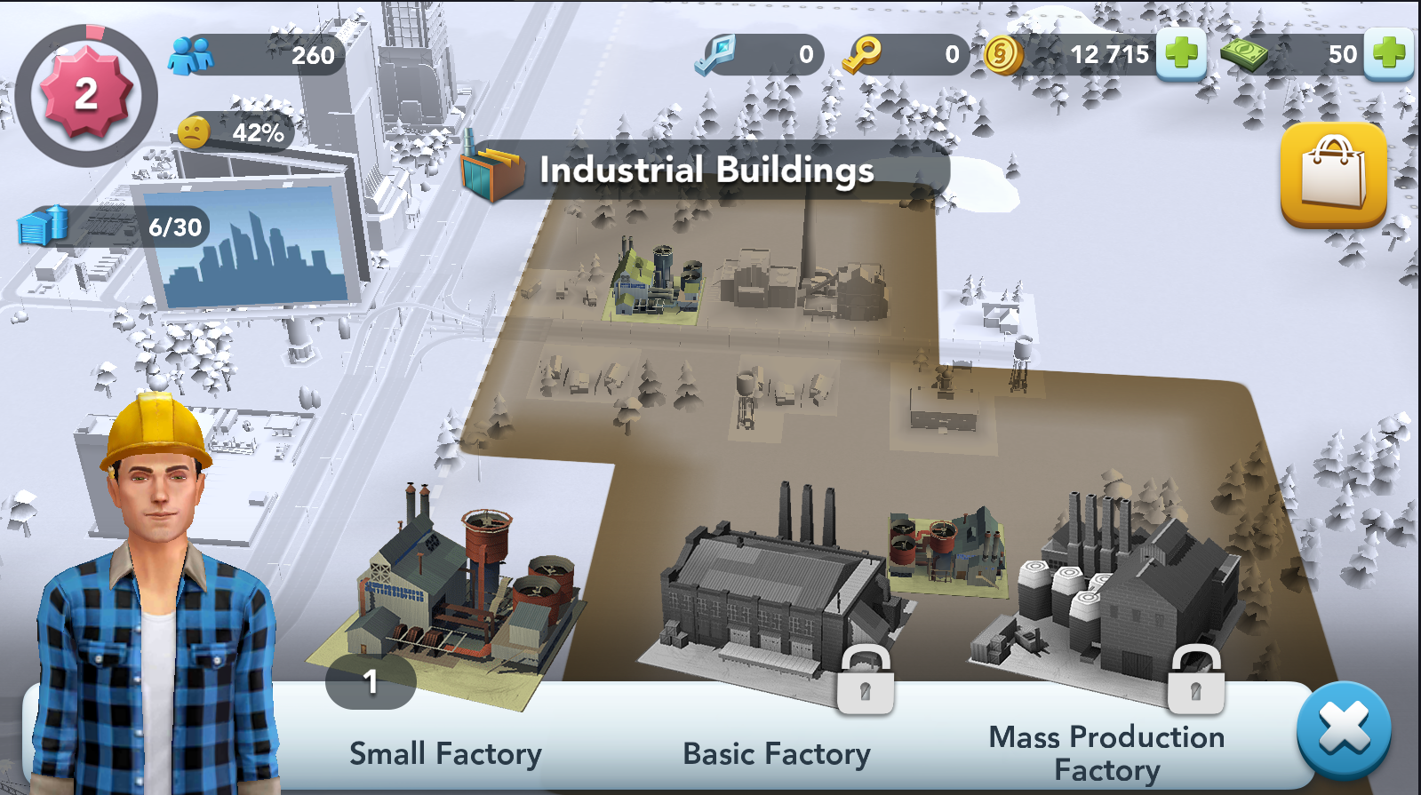
When you select any building in the "Plants" menu, you will see information on how to arrange various plants in the city:
- The cost of the building. How much will the construction of the building and commissioning cost?
- Performance. Goods in factories can be produced in parallel, no need to wait until the production of one type of product is completed in order to start production of another! The more production cells a plant has, the more goods you can produce at the same time.
- Radius of contamination. We need plants, but nobody really wants to live next to them. Plants spread pollution over a certain distance, known as the pollution radius (displayed in brown on the map in factory mode), and the townspeople do not like to live next door to them. Try to place plants away from residential areas and do not forget to upgrade them if possible, turning them into cleaner and more efficient ones with a smaller radius of pollution!
- Requirements. How much population is required to unlock the building.
6.As you progress in the game, you will be able to unlock more sites for production - they allow you to place more plants in the city. When new production sites become available, a number appears next to the plant's icon.
How to produce goods? Press and hold any product name in the factory to view:
- Production time - how long will the production of goods take.
- In the city warehouse - how many units of this product are already in your stock.
- If the product is not available , what level do you have to reach in order to unlock it?
7.As you progress through the game, you will discover new production formulas and a wider selection of commercial buildings. Click on the icon of commercial buildings on the right of the screen to see a list of commercial buildings, including those currently operating in the city, and those that can be built.
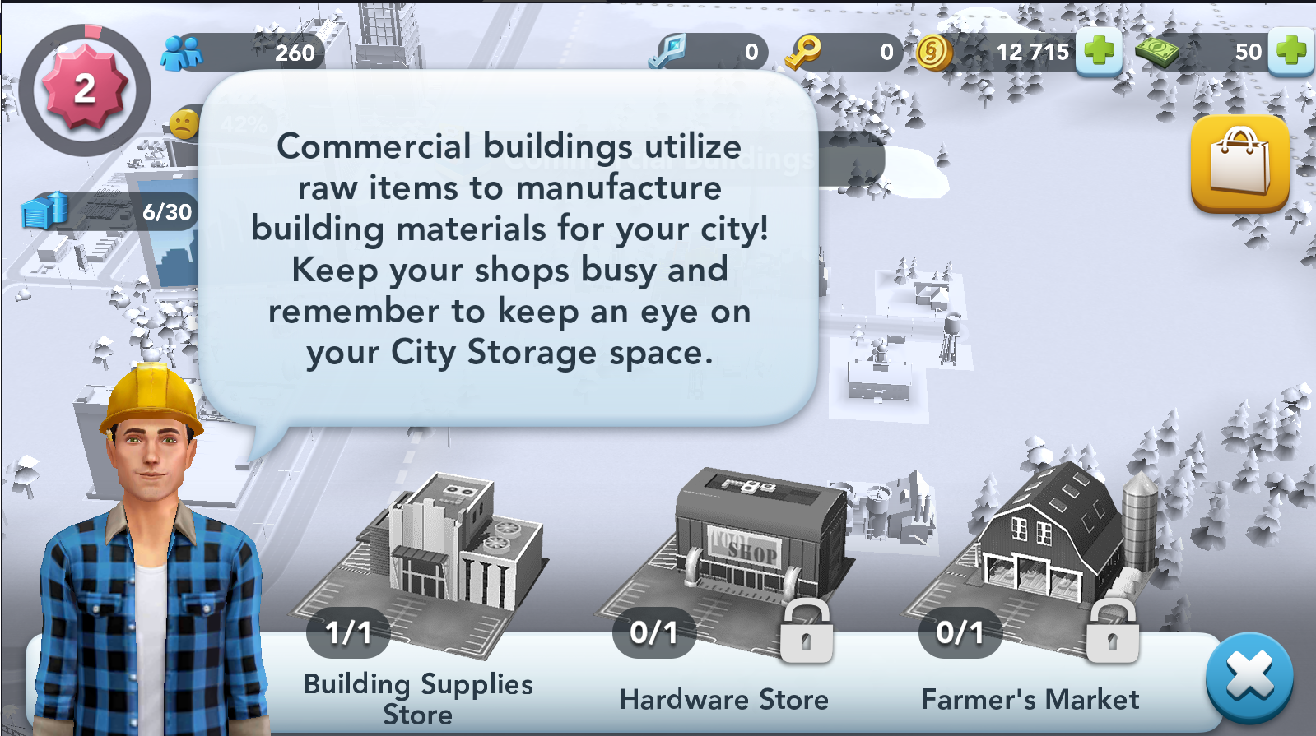
When you select any building from the Commercial Buildings menu, you will see information on how to place it in the city.
- Building cost - how much will it cost to build a building and put into operation.
- Requirements - what level of experience is needed in order to unlock the building.
How to start the production of goods in commercial buildings? In a commercial building, tap and hold on a product to view:
- Production time - how long will the production of goods take.
- In the city warehouse - how many units of this product are already in your stock.
- Materials Needed - What materials do you need for this production recipe.
- If the product is unavailable , what level is required to unlock it.
How to buy goods from other cities? As soon as the number of your population reaches a certain level, the head office of World Trade Operations will become available to you. You will find it on the main highway outside the city.
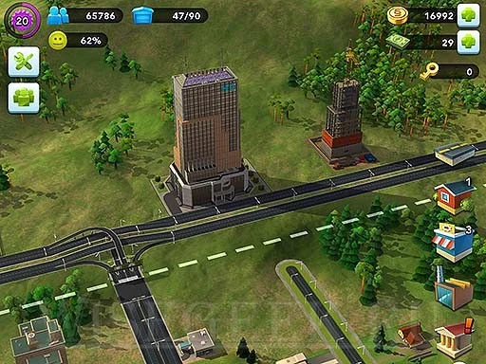
Here you can see the advertised goods from other cities and find out if there are any of them that interest you. Remember that the price of a lot is determined by the seller, so look who offers the best price!
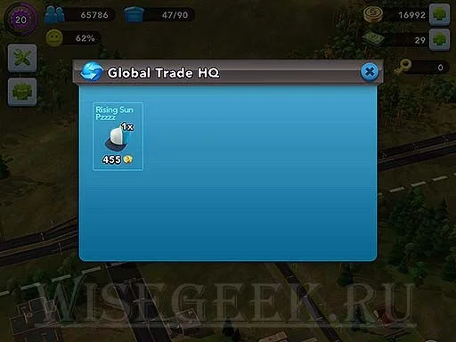
SimCity BuildIt: Construction and Modernization of Residential Areas
Click on the living area icon on the screen to the right. Now you will see residential buildings on the city map, as well as useful information - the total number of buildings, how many buildings can be modernized and how many abandoned buildings.
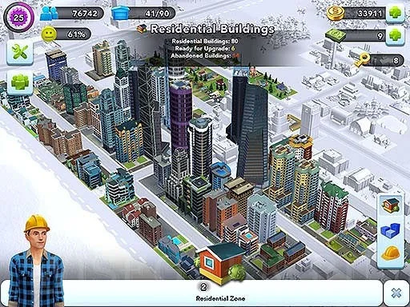
Click on the blue stripe icon to see a map of the city in various shades of blue. They indicate the value of land in your city! The darker the shade is blue, the more desirable is the housing in the area; this means that there are city services and specializations.
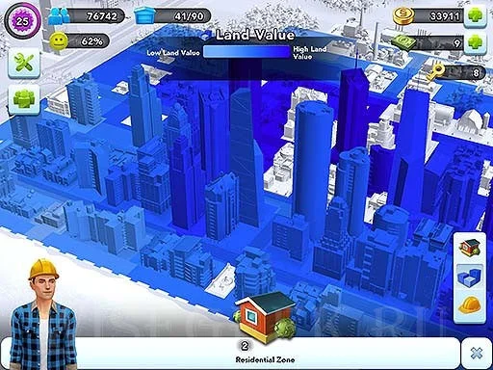
click on the yellow helmet to see the weather forecast. Make upgrades in the dark orange areas, and after it the buildings will look very luxurious!
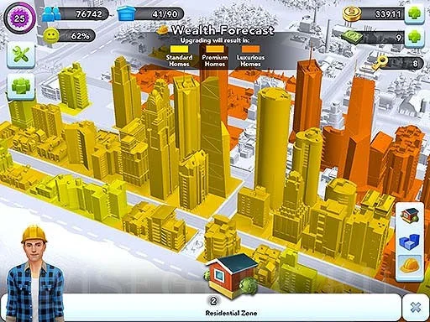

SimCity BuildIt: Road Construction and Maintenance
Click the road icon on the right of the screen to check the status of your road system.
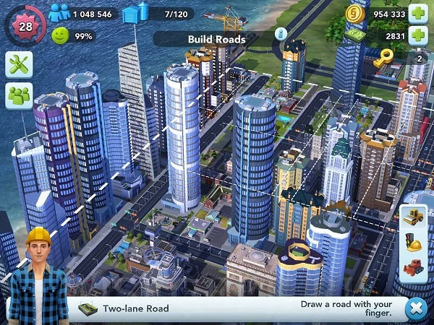
Modernization of roads. Click on the upgrade icon with helmet and traffic light. You will see a view of the city with a highlighted road network. Green / black roads = good. Red roads = bad!
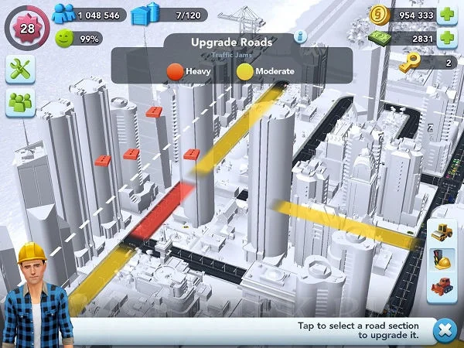
To build buildings providing regional services, use the "Services" section in the menu of specialization buildings and city services, the icon of which is located in the lower right corner of the screen with your city.
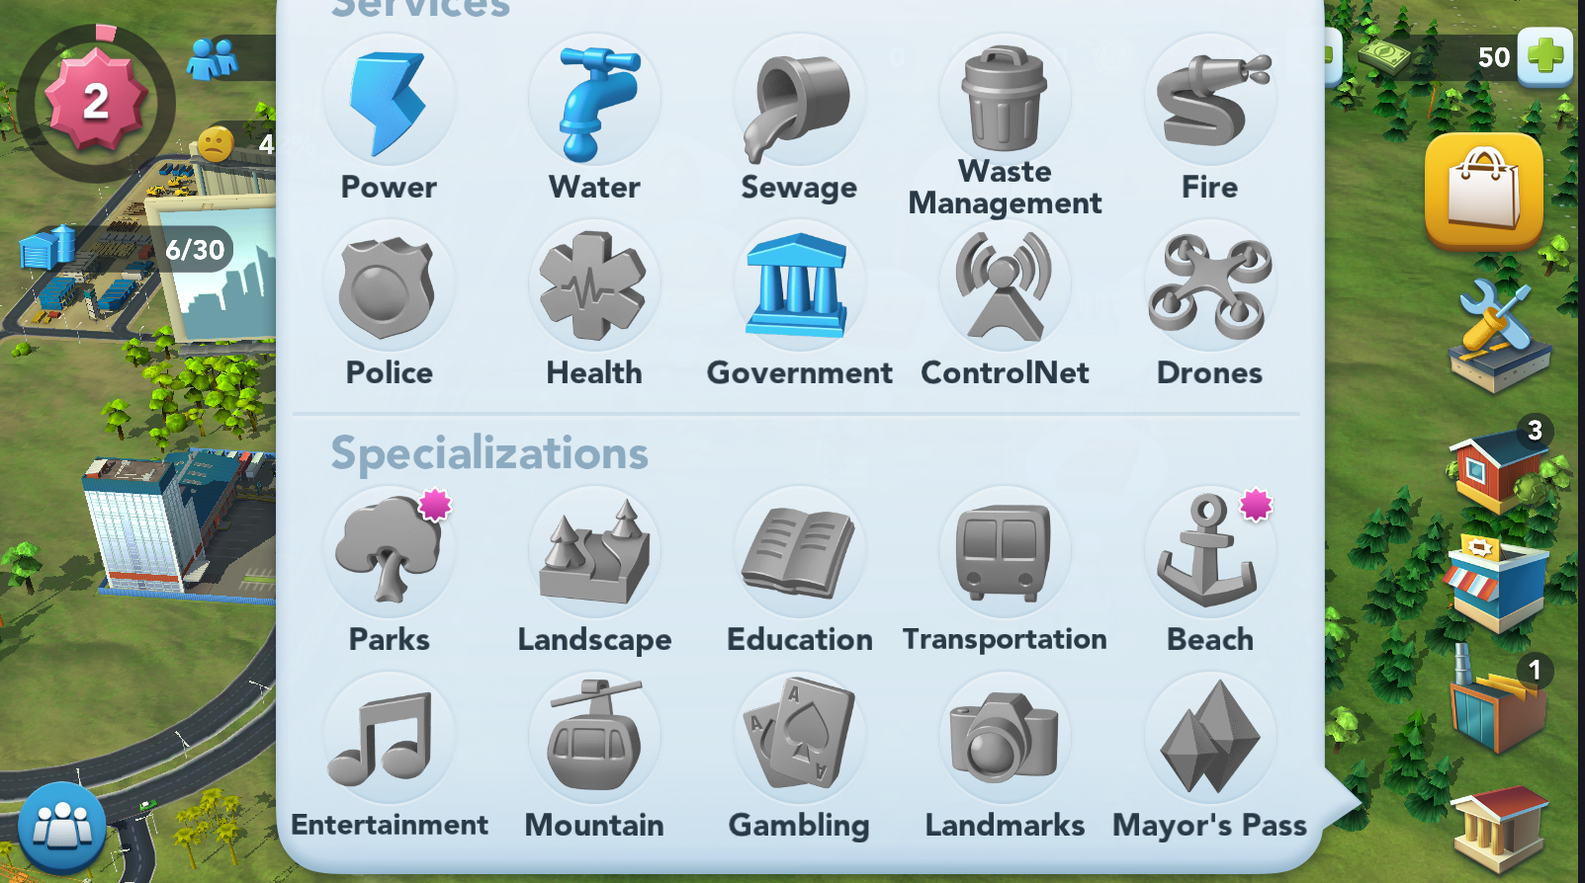

Basic Features
The basic functions of SimCity allow you to:
▪ Construction of modernization of residential areas
▪ Road construction and maintenance
▪ Purchase, sale ,delivery of goods and conclusion of transaction

This tutorial will walk you through the basics of creating a city building.
To navigate to a particular section of the video, click on the content next to the timestamps below:

SimCity Buildit Layout Level

SimCity Buildit Factories & Upgrades

SimCity Buildit Parks & Population

SimCity Build It Commercial Buildings

SimCity Buildit Fire Services

SimCity Buildit Building Capacity vs. Demand

SimCity Buildit Trade Depot & Global Trade Headquarters

SimCity Buildit Sim Offers & Opinion Bubbles

SimCity Buildit Wealth Forecast and Land Value

SimCity Buildit Cargo Ship Delivery

SimCity Buildit Specializations

SimCity Buildit Police Services

SimCity Buildit Fire & Police Coverage Layout

SimCity Buildit 14: Waste Management

Troubleshooting
Building a city on SimCity can be an intricate process that requires some attention to detail, depending on the complexity of your design. Here are a few tips to help you if you run into trouble:
- Before you begin designing, ensure you have a stable internet connection.
- Head over to the FAQ section by clicking here if you have questions about the platform.
- Review the controls and keyboard shortcuts with your learners at the beginning of each session and display them around the classroom for learners to refer.

