Beginners Guide to Thunkable: Creating Mobile Apps for Learners
Introduction
Thunkable is a platform that allows learners to create their own mobile apps without any coding experience. Thunkable allows learners to design and develop interactive and engaging mobile applications using a visual drag-and-drop interface. This tutorial will guide you through the process of creating a mobile app using Thunkable.
How to get started?
To get started with Thunkable, follow these steps:
- Visit the Thunkable website at https://thunkable.com/.
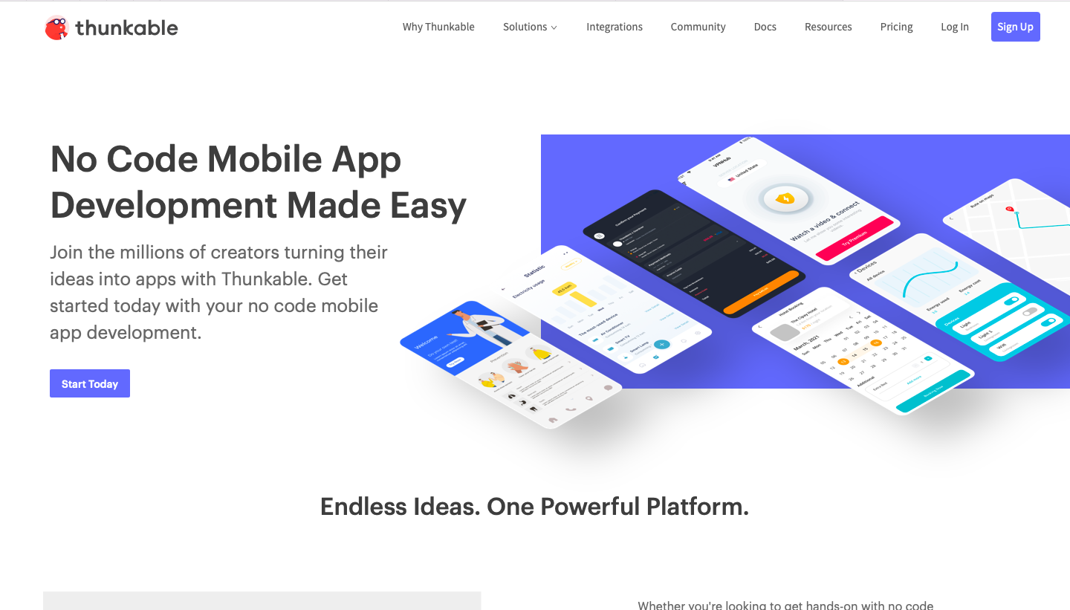
- Click on the "Sign Up" button to create your account.
- Sign up using your email address and choose a secure password.
- Once signed in, you'll be redirected to the Thunkable project dashboard.
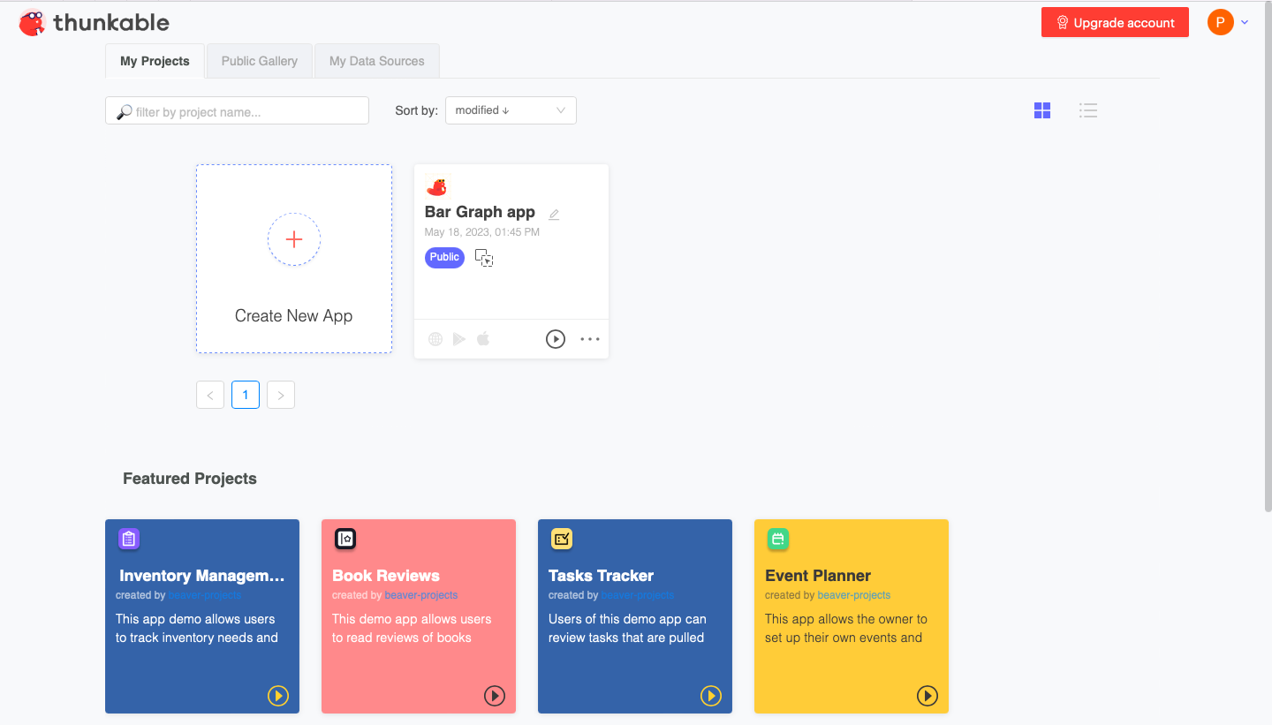

Tech Check
Here's what you need to get started with Thunkable:
- A computer with internet access.
- A web browser (Google Chrome or Mozilla Firefox is recommended).
- A stable internet connection.
Creating your first project
- After signing in, click the "Create New Project" button on the dashboard.
- Name your project and choose a category for your app.
- You will be redirected to the Thunkable App Editor, where you can design and customize your app's user interface.
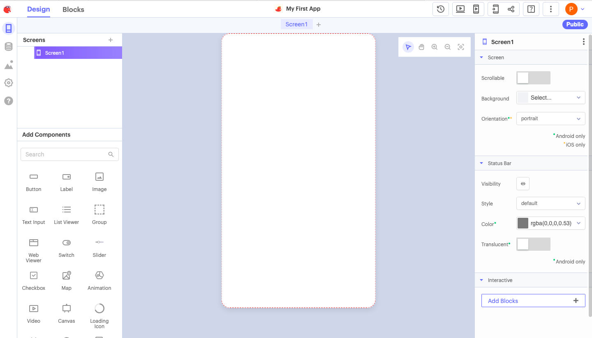

Designing the app interface
- On the left-hand side, you'll find the components palette. Drag and drop the desired components onto the app screen.
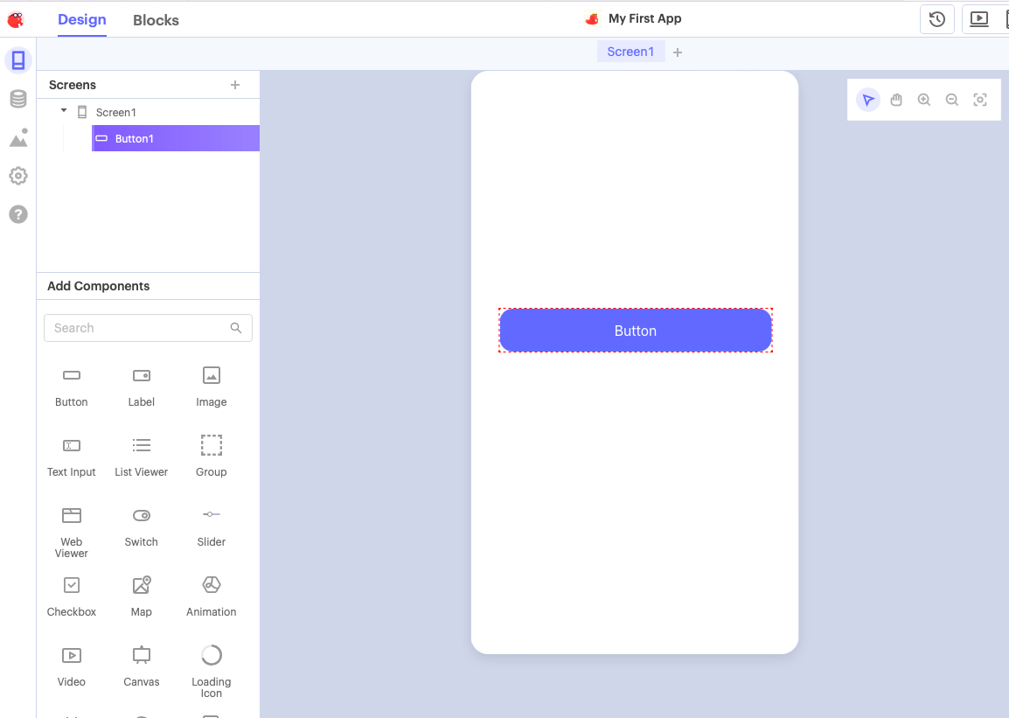
- Customize the components' properties and appearance using the properties panel on the right-hand side.
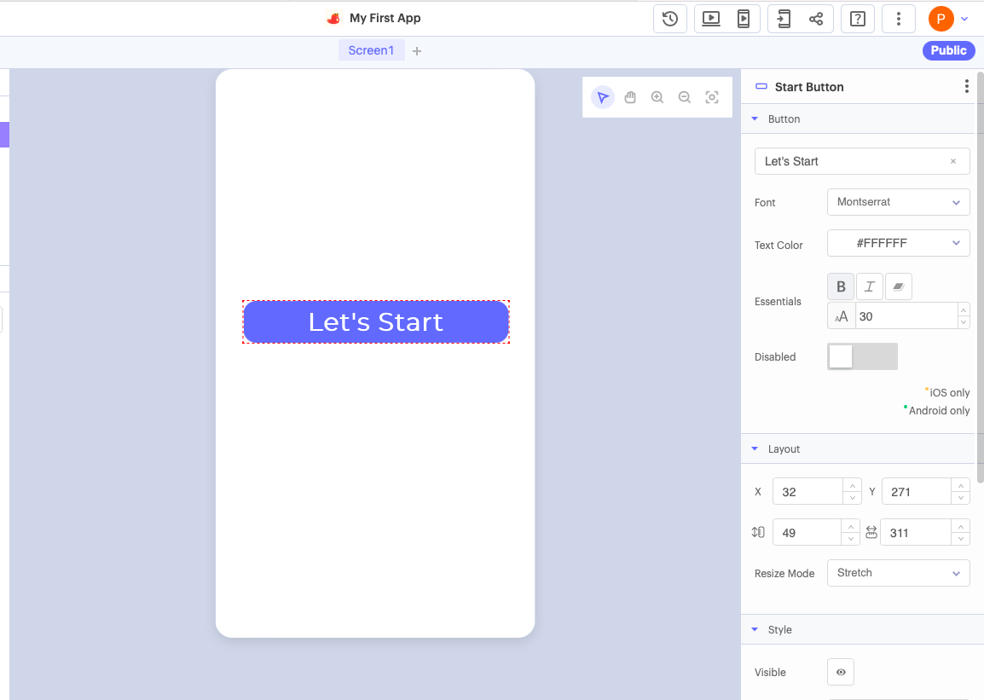
- Arrange the components on the screen to create your desired layout.
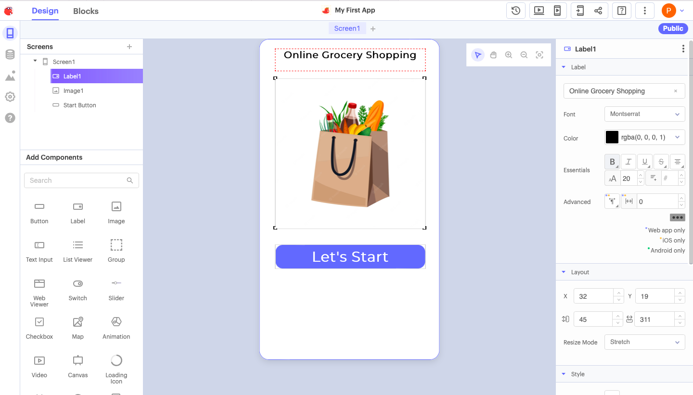
Adding functionality to your app
- To add functionality, select a component and choose an event from the blocks palette on the left-hand side.
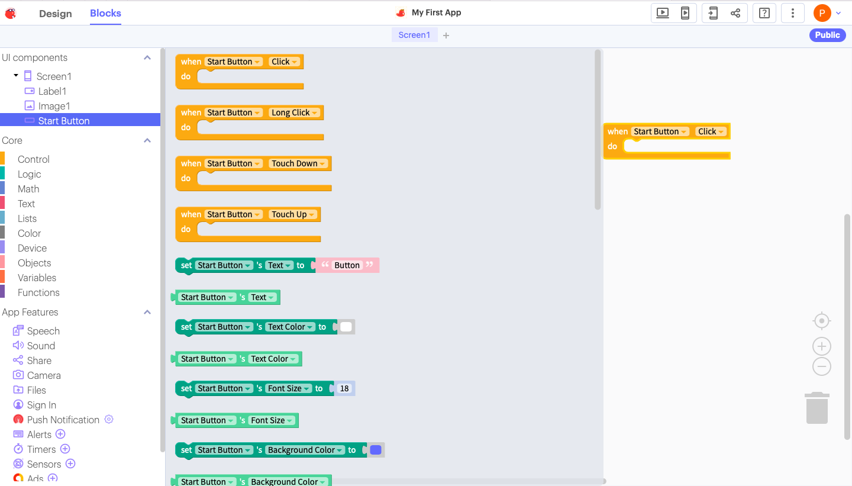
- Drag and drop blocks to create event handlers and define app behavior.
- Use blocks to implement actions, logic, and interactions in your app.
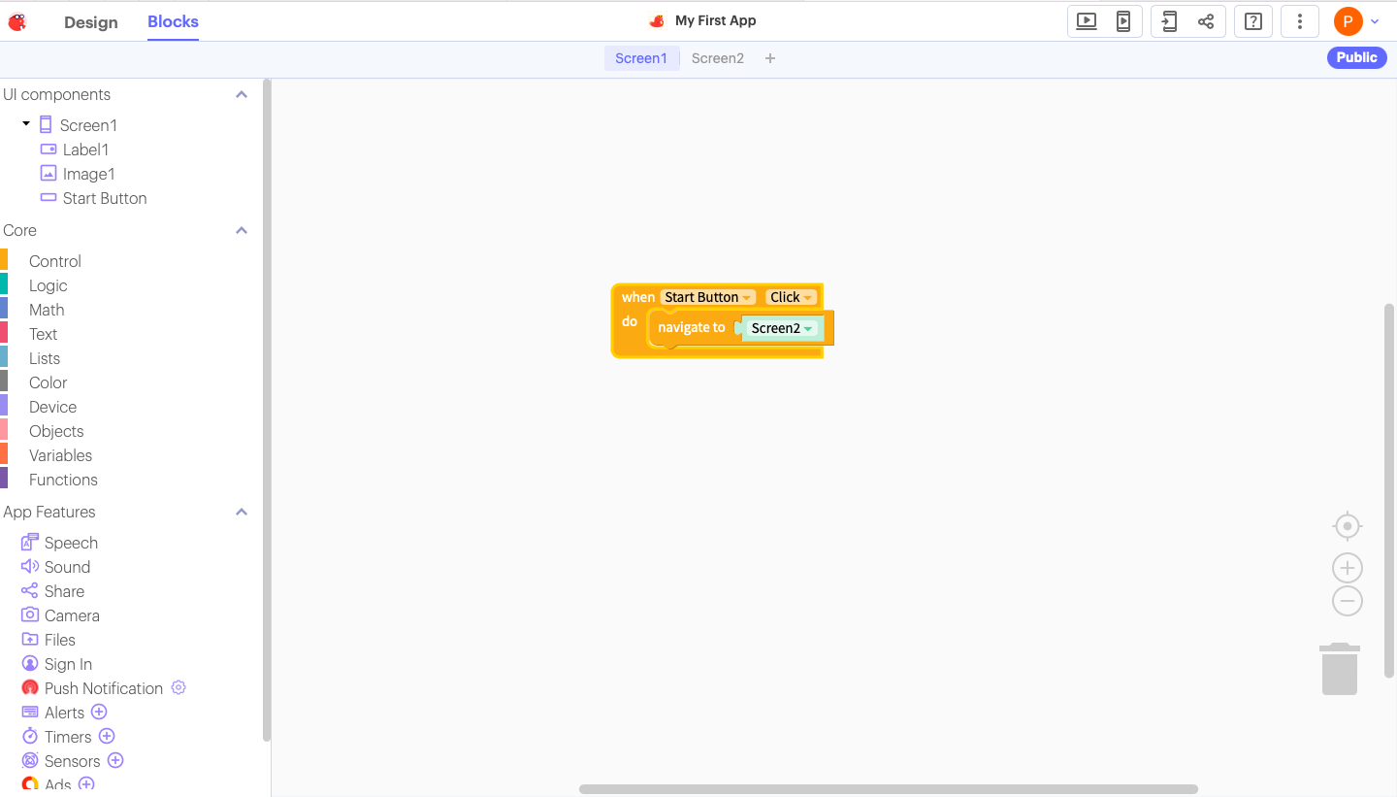
Testing your app
- To test your app, click the “Preview” button at the top-right corner of the Thunkable App Editor.
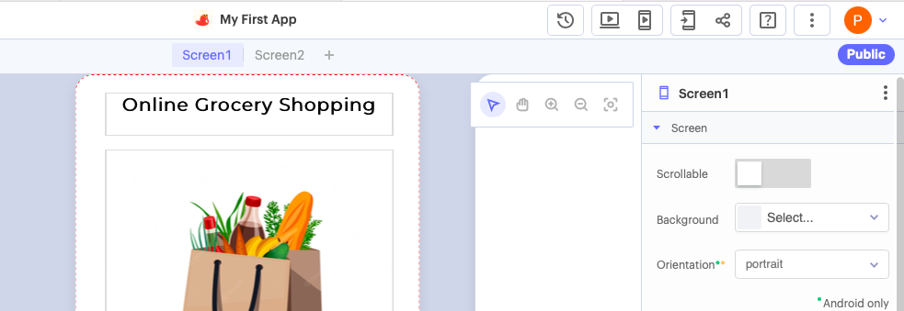
- Thunkable will generate a QR code that you can scan with your mobile device to preview the app on a mobile device.
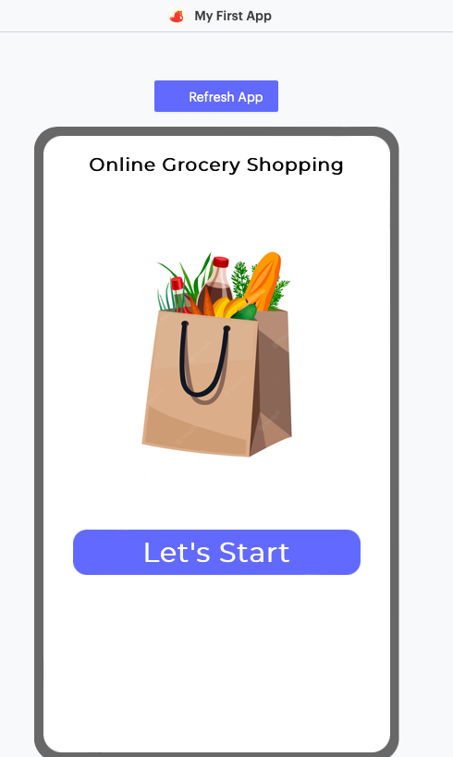
- Alternatively, you can use the Thunkable Live app available on the App Store or Google Play Store to preview your app instantly.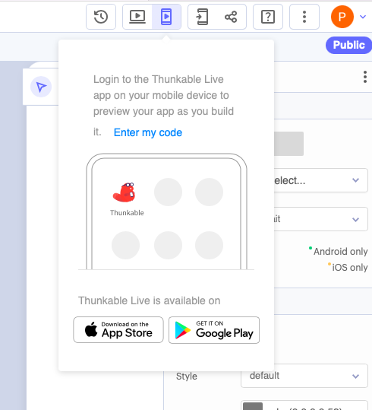
Publishing your app
- Once satisfied with your app, click on the "Publish" button.
- Follow the prompts to export your app as an APK (for Android) or IPA (for iOS) file.
- You can then distribute your app by uploading it to the respective app stores or sharing the installation file.

Thunkable is a platform that allows you to build mobile apps without requiring extensive coding knowledge. Some of the essential functions of Thunkable include:
- Drag-and-Drop Interface: Thunkable provides a visual interface where you can design your app by dragging and dropping components. This feature makes creating your app’s user interface easy without writing code.
- Component Library: Thunkable offers a wide range of pre-built components you can use in your app, such as buttons, text boxes, images, lists, and more. These components enable you to add functionality to your app without starting from scratch.
- Block-Based Programming: Thunkable utilizes a block-based programming paradigm, similar to Scratch or Blockly. You can define the behavior of your app by snapping together blocks that represent different actions, events, and logic.
- App Testing: Thunkable allows you to preview and test your app in real-time on connected devices or through the Thunkable Live app. This feature helps you ensure that your app functions correctly before publishing it.
- Data Integration: Thunkable enables you to integrate various data sources into your app. You can connect to databases, APIs, and services to fetch and store data, enabling your app to interact with external systems.
- Cross-Platform Development: With Thunkable, you can create apps that work on both Android and iOS devices. This cross-platform capability saves time and effort by eliminating the need to develop separate apps for each platform.
- Publishing and Distribution: Once your app is ready, Thunkable provides options for publishing and distributing your app to app stores, such as Google Play Store and Apple App Store. You can generate APKs or IPA files for deployment.
This tutorial will walk you through the basics of creating a project on “Thunkable.”
To navigate to a particular section of the video, click on the content next to the timestamps below:
- Intro
- Design Tab
- Blocks
- Data Source
- Click Event
- Drag Drop
- Label
Troubleshooting Tips
Creating an app in Thunkable can sometimes encounter challenges. Here are a few troubleshooting tips to help you out:
- Check your internet connection: Ensure you have a stable internet connection before working on your app.
- Thunkable Help Center: If you have any questions or encounter issues, visit the Thunkable Help Center for documentation and support.
- Forums and Communities: Engage with Thunkable's vibrant user community to get help, share ideas, and find inspiration.
- Tutorials and Resources: Explore Thunkable's official tutorials, video guides, and documentation to learn more about app development.

Conclusion
Thunkable provides a fantastic platform for learners to unleash their creativity and build their mobile apps. Following this tutorial taught you the basics of creating an app using Thunkable. Experiment with different components, events, and features to make your app unique and enjoyable. Happy app building!

