Group No./Name: ____________ Date: ____________

Circuit Prototyping on Tinkercad
Using the following items, create your circuit design on Tinkercad!
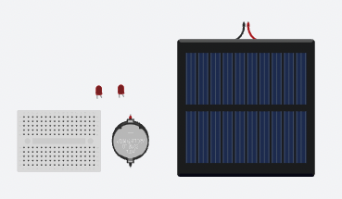
3V Battery
Solar panel
LED Lights
Mini breadboard
Activity 1: Diagram
Compare your circuit diagram on Tinkercad with the previously made diagram. Do you wish to make any changes? Draw the revised circuit diagram below.

