Name: ____________________

**DAY 1: FInding the appropriate location for the Smith family**

You are a solar engineer responsible for advising the Smith family of four who are planning to relocate from Minnesota to the Boston area, specifically the Boston/Cambridge region. The family is keen on harnessing solar energy and wishes to install solar panels on their new home. Your task is to:

1. Evaluate the shortlisted locations provided by the family and recommend the most suitable location for optimal solar panel installation.
2. Additionally, you will design the layout of the solar panels on their prospective home, taking into consideration factors such as roof orientation, available space, and aesthetic considerations.

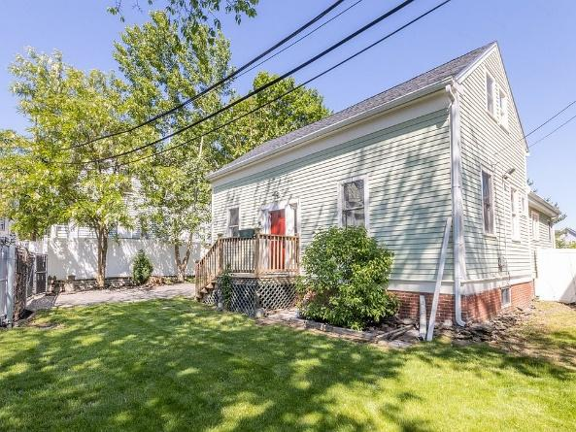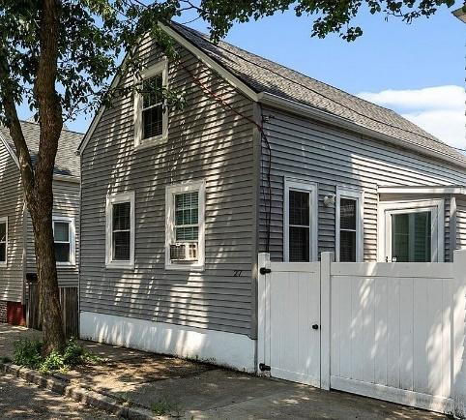

They have provided information about the power ratings and durations of use for various appliances in their household. Using the given data, estimate the monthly electricity bill for the family.

| **Appliance** | **Power Rating (in watts)** | **Duration of Use (in hours)** | **Number of Appliances** | **Total power consumed in 30 days (in Kw)** |
| --- | --- | --- | --- | --- |
| Television | 60 | 4 | 1 | 7.2 |
| Light Bulbs | 20 | 6 | 10 | 36 |
| Air Conditioner | 1000 | 8 | 1 | 240 |
| Fan | 75 | 12 | 2 | 54 |
| Microwave | 800 | 0.5 | 1 | 12 |
| Refrigerator | 200 | 24 | 1 | 144 |
| Electric Oven/Stove | 2500 | 2 | 1 | 150 |
| Dishwasher | 1200 | 1 | 1 | 36 |
| Computer/Laptop | 80 | 4 | 2 | 19.2 |
| Water Heater | 1200 | 1 | 1 | 36 |
| Clothes Dryer | 1500 | 1 | 1 | 45 |
| **Total monthly electricity consumed (in Kw)** |  |  |  | 779.4 |

*Assume an electricity rate of $0.25 per kilowatt-hour, which is the current rate in the Boston/Cambridge area.*

**Estimated monthly electricity bill: $194.85 (this can be rounded off to $ 200)**

**Estimated yearly electricity bill: $2338.2**

Google Sunroof is an innovative tool that uses satellite imagery and advanced analytics to evaluate the solar potential of a property. By analyzing various factors such as the size, shape, and orientation of the roof, as well as potential shading from nearby objects, Google Sunroof provides valuable insights into the feasibility of installing solar panels and the potential benefits associated with them.

So, why is it important for us to use Google Sunroof? Well, by utilizing this tool, we can gather essential information about the solar potential of a property in the Boston/Cambridge area. This information will help us determine whether installing solar panels is a practical and cost-effective solution for the Smith family, who are considering a move to this area.

Detailed instructions on how to use Google Sunroof:

**Access Google Sunroof**: Open a web browser and go to the Google Sunroof website (<https://www.google.com/get/sunroof>).

**Enter Location**: On the Google Sunroof homepage, you will see a search bar. Enter the address or location of the property in the Boston/Cambridge area where the Smith family is considering moving. For example, you can enter "123 Main Street, Cambridge, MA."

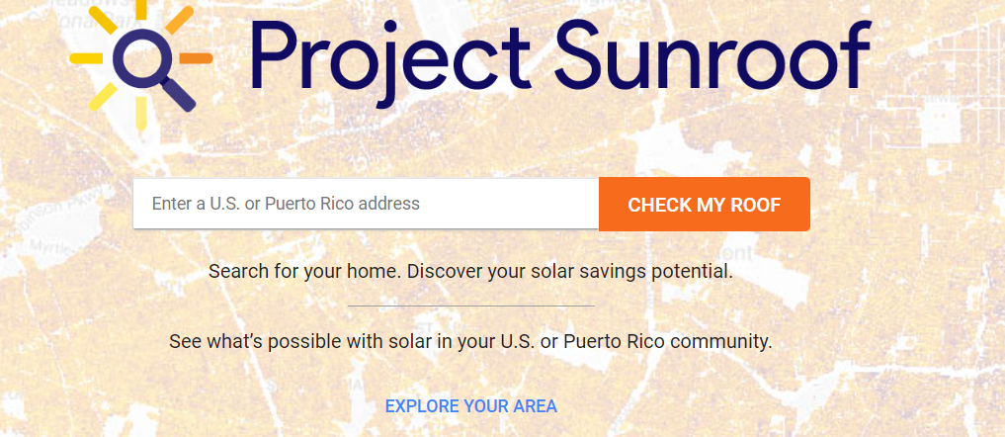

**Explore the Roof Analysis**: Once you have entered the location, Google Sunroof will display an aerial view of the property. The website uses satellite imagery and 3D modeling to analyze the roof's solar potential. You can explore the analysis by interacting with the map.

**Zoom In/Out**: Use the zoom buttons on the map or scroll with your mouse to zoom in or out for a closer look at the property.

**Pan the Map**: Click and drag the map to move around and explore the surrounding area.

**Select the Roof**: Click on the roof area of the property to select it for further analysis.

**View Solar Potential**: After selecting the roof area, Google Sunroof will display an overview of the property's solar potential. It will provide information such as the total solar potential, available sunlight hours, and estimated energy savings.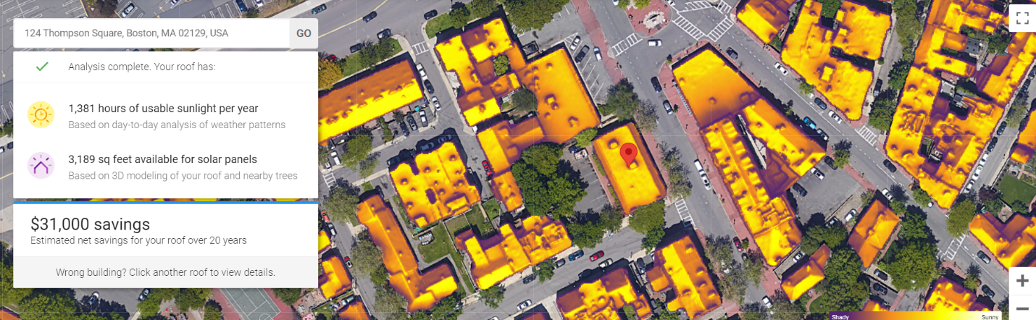

**Explore Detailed Information**: Scroll down to explore more detailed information about the property's solar potential. This may include estimated electricity generation, potential carbon offset, and financial savings.

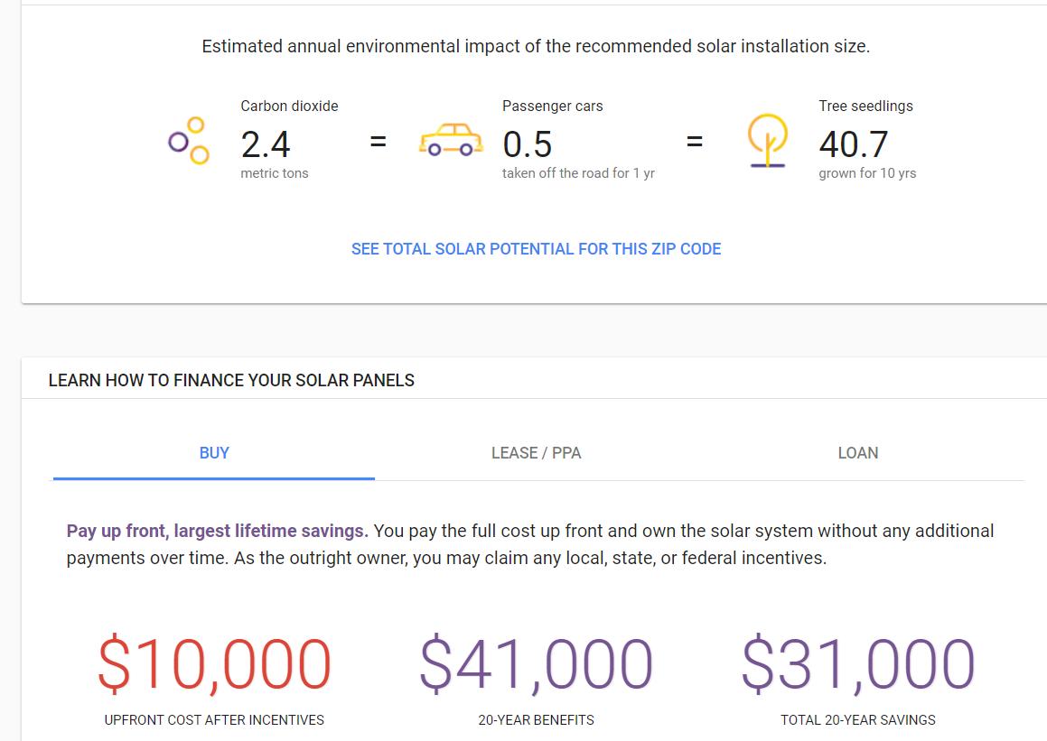

**What are SRECs?**

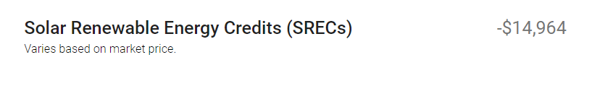

* SRECs are generated when a solar energy system produces **one MWh of electricity**.
* Solar system owners must register their system and certify the SRECs with the appropriate regulatory authority or SREC program administrator.
* SRECs can be sold in the market to electricity suppliers and utilities to help them meet their renewable energy requirements.
* The price of SRECs is determined by market forces, and solar system owners can earn revenue by selling them at the market price.
* SREC revenue provides an **additional income stream** that can offset the upfront costs of installing and maintaining a solar energy system.

Using Google Sunroof to assess the four locations chosen by the Smith family in Boston/Cambridge.

* Option 1: 2 Cleveland St, Cambridge, MA 02138, USA.
* Option 2: 15 Chalk St, Cambridge, MA 02139, USA.
* Option 3: 46R Payson Ave, Dorchester, MA 02125
* Option 4: 27 Winter St, Cambridge, MA 02141

Based on the analysis conducted using Google Sunroof to assess solar potential, which specific house among the four locations should the Smith family consider moving into for optimal solar panel installation? Justify your recommendation.

| 2 Cleveland St, Cambridge, MA 02138, USA. – Surrounded by trees, insufficient available roof area  15 Chalk St, Cambridge, MA 02139, USA. – Less available sunlight throughout the year, surrounded by too much trees, least savings in 20 years.  46R Payson Ave, Dorchester, MA 02125 – Adequate available sunlight, sufficient roof area, decent savings. **This house should be selected**  27 Winter St, Cambridge, MA 02141 – Surrounded by trees and buildings, less available roof area.  *Alternatively, students can also present their findings in a tabular form then compare to suggest with the most viable house.*   |  | Available sunlight | Roof area | Shading from nearby trees and buildings | Overall savings | | --- | --- | --- | --- | --- | | House 1 |  |  |  |  | | House 2 |  |  |  |  | |
| --- | --- | --- | --- | --- | --- | --- | --- | --- | --- | --- | --- | --- | --- | --- | --- |

Readings: [**https://www.dosolar.com.au/types-of-solar-power-system/**](https://www.dosolar.com.au/types-of-solar-power-system/)

Based on the solar potential data obtained from Sunroof, should the Smith family consider implementing an on-grid or off-grid solar system for their selected location? Justify your recommendation based on the solar energy generation potential and the availability of utility grid connection in the area.

| Google sunroof shows SREC as a part of the savings so, it has to be a on-grid system. |
| --- |

Considering the recommended installation size for the solar panels, how do you think the tilt angle impact the energy output? (*Hint: Residential solar panels exhibit a range of power output, typically between 250-300. Why do you think there is a range?)*

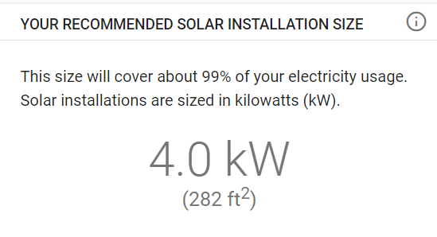

| A proper tilt angle helps capture more sunlight and can be crucial for achieving optimal energy production. The optimal tilt angle considers factors such as the location's latitude, seasonal variations, and potential reflection and shading issues. |
| --- |

To determine the optimal tilt angles and the maximum power output achievable from the system, we will utilize PVWatts, a widely-used tool for solar energy system analysis. By employing PVWatts, we can calculate the ideal angles and evaluate the potential power generation capacity of the solar system.

**Access the PVWatts Tool**: <https://pvwatts.nrel.gov/>

**Enter Location Details:**

In the "Location" section, input the address or coordinates of the desired location (e.g., city, state, or specific address) where you plan to install the solar panels.

Alternatively, you can click on the map icon next to the address field to pinpoint the location manually. **Once done click on go to system info.**

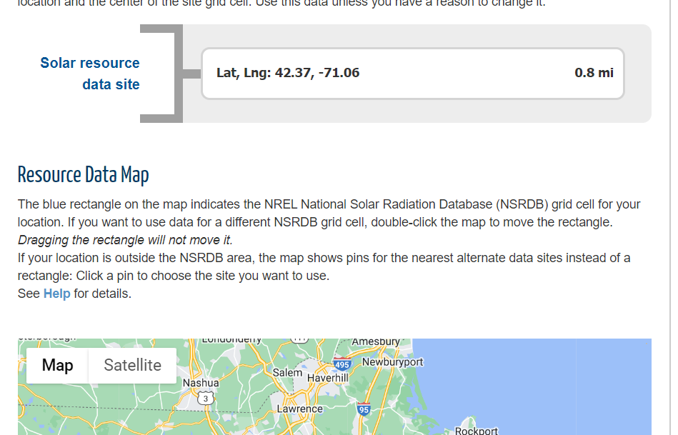

**Adjust the "System Info" section:**

In the "DC System Size" field, specify the size of the solar panel system in kilowatts (kW).

In the "Module Type" drop-down menu, you can slelct the appropriate module type based on the type of solar panels you plan to use (e.g., standard, premium, thin film). **Select standard**

In the "Array Type" drop-down menu, you can choose different configuration setup (e.g., fixed, 1-axis tracking, 2-axis tracking). **Select fixed (open rack)**

The desired tilt angle and azimuth (orientation) of the panels depends on the installation location and requirements.

Set the Azimuth to 180. You need to suggest an optimum value of the tilt angle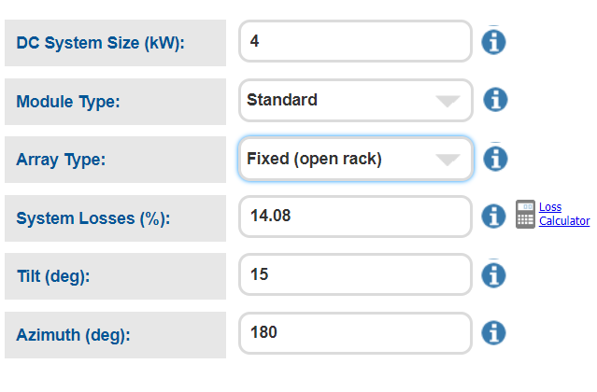

***The DC system size is to be taken from the google sunroof project. (9.5 Kw)***

***Only change the tilt.***

***Do not change the advance parameters.***

***Click on go to PVWatts results to get the power output.***

| **Tilt angle in degrees** | **Power output per year in Kwh** |
| --- | --- |
| 10 | 11,703 |
| 15 | 12,069 |
| 20 | 12,342 |
| 30 | 12,611 |
| 35 | 12,613 |
| 40 | 12,532 |

The solar panels should have tilt angle of **30-35 degrees**

***Note: 30-35 degrees’ tilt angle is the most optimum tilt angle for houses in Boston***

To simulate a rough design using Tinkercad, we will utilize the available components such as a solar cell, batteries, four bulbs, and two motors (fans). Although it's important to note that the exact components may not be available in the Tinkercad library, we can still create a simulated representation of the design. By using similar components with comparable functionalities, we can approximate the behavior and interactions of the actual components. The objective is to visualize the connections and relationships between the solar cell, batteries, bulbs, and motors in a coherent manner, demonstrating how the solar energy is harnessed, stored in the batteries, and subsequently used to power the bulbs and motors.

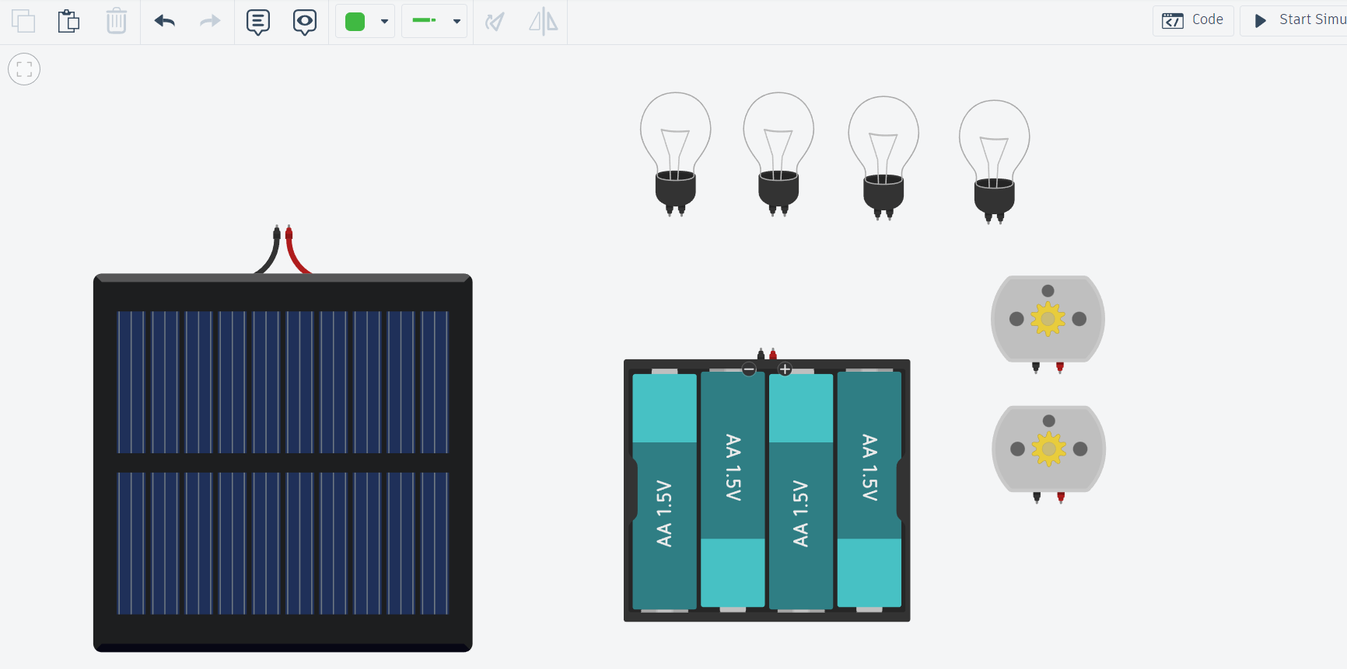

| **Steps** | **Description** | **Calculation** | **Results** |
| --- | --- | --- | --- |
| 1.a | Initial cost of solar panel installation | From Google Sunroof | $31,704 |
| 1.b | Incentives for solar installation | 30% of 1.a | $9511.2 |
| 2.a | Total energy production over 20 years | Energy production per year x 20 | 12,600 × 20  = 252,000 Kw |
| 2.b | Total energy consumption over 20 years | Energy consumption per year x 20 | 780 × 12 × 20  = 187,200 |
| 2.c | Total spent on utilities over 20 years (with solar)  Unit price = $ 0.25 | From Google Sunroof | $4,756 |
| 2.d | Total spent on utilities over 20 years (without solar)  Unit price = $ 0.25 | From Google Sunroof | $59,668 |
| 3.a | Calculate SREC credits | (2.a – 2.c)/1000  (*To convert into MWh it is divided by 1000 as above)* | 64.8 |
| 3.b | Additional revenue from SREC  (Cost = $300/MWh/SREC) | 3.a × $300 | $19,440 |
| 4.a | Total cost without solar | 2.d | $59,668 |

Estimate the total savings in 20 years by using solar panels. Show the steps in detail.

| Total Expenditure = (1.a – 1.b) + 2.c  = $26,946  Savings = 2.d + 3.b  = $79,068  Net savings = $79,068 - $26,946 = $52,122  The numbers were taken to simplify the calculation for the students.  *The electricity consumption may not remain same for the entire 20 years.*  *The electricity production would also vary.*  *The increase in the cost of SREC credit was not considered.*  *The NPV of the final savings was also left out.*  *\*\*Net Present Value (NPV) is a financial metric used to determine the value of an investment or project by comparing the present value of expected cash inflows with the present value of expected cash outflows. It helps assess the profitability and viability of an investment or project over time.* |
| --- |

Compare the savings with that of the sunroof project. Why do you think it is different?

| Possible reasons of the difference in total savings   1. Electricity generated is different due to the tilt of the panels being considered. 2. The Cost of SREC credit was different. |
| --- |

Carbon footprint refers to the total amount of greenhouse gases, primarily carbon dioxide (CO2), emitted directly or indirectly by an individual, organization, event, or product over a specific period. It measures the impact human activities have on the environment in terms of contributing to climate change. The carbon footprint quantifies the amount of CO2 and other greenhouse gases released into the atmosphere, often measured in metric tons or kilograms of CO2 equivalent.

**Equivalence calculator:** [**https://www.epa.gov/energy/greenhouse-gas-equivalencies-calculator**](https://www.epa.gov/energy/greenhouse-gas-equivalencies-calculator)

Use the below tool to compare the carbon dioxide emission with and without the solar installation.

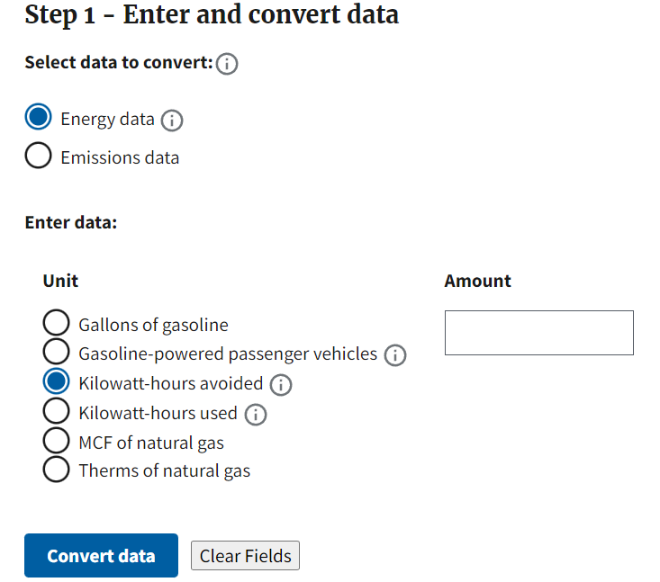

|  |
| --- |

1. Why isn't solar power more widely adopted despite its effectiveness?

| *Possible answers include:*  High initial costs: While solar panels have decreased over the years, the upfront installation costs can still be significant.  Availability of alternative energy sources: In some regions, other forms of energy, such as fossil fuels or hydroelectric power, are readily available and cheaper to use.  Grid Capacity: The electrical grid has limitations on how much intermittent renewable energy, such as solar power, it can handle. If many solar systems in a specific area generate surplus electricity simultaneously, it can exceed the grid's capacity and cause stability issues. To avoid such problems, grid operators may limit the amount of solar power they accept from individual consumers.  Technical Compatibility: Solar power systems need to be compatible with the existing grid infrastructure to facilitate the transfer of electricity. However, in certain cases, older grids may not be equipped to handle bidirectional energy flows efficiently.  Economic Viability: Selling excess solar power back to the grid may not always provide attractive financial incentives. In some regions, the compensation rates for grid selling are lower than the retail rates for purchasing electricity from the grid. |
| --- |

2. What are the implications of increasing the number of solar panels? Why don't we simply install more solar panels to increase energy generation?

| The cost of scaling up solar installations can be a significant upfront investment.  Balancing energy supply and demand is crucial when increasing solar power capacity.  Diminishing Returns: Adding more solar panels does lead to an increase in energy generation. However, there comes a point where the additional panels may not proportionally increase the overall energy output. This is because factors such as limited space, shading, and grid constraints can limit the effectiveness of each additional panel. |
| --- |

Will the efficiency of solar panels decrease over time? Justify. What can you do to minimize the decrease in efficiency?

| Over time, solar panels face wear from environmental factors like sunlight, temperature fluctuations, moisture, and dirt, leading to decreased efficiency. Dust accumulation further reduces the amount of light reaching the solar cells.  Regular maintenance and cleaning help combat these issues and maintain optimal performance. |
| --- |