Name: _______________
Bowling with Friction
Observe and analyze the different boxes as they slide down the inclined plane.
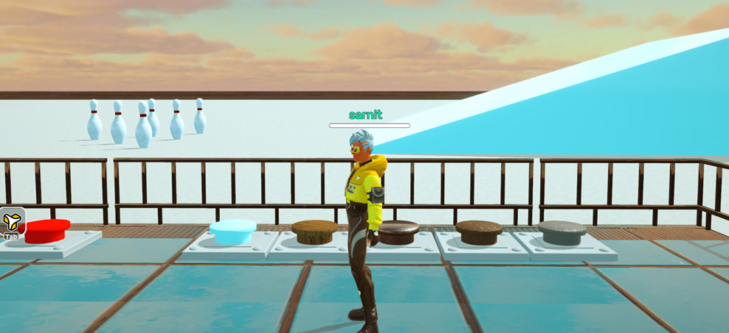
A
C
B
D
E
Bowling pins
Inclined plane
Note: Five buttons drop a box of different materials onto the inclined plane.

As your teacher plays the game, fill in the table below with your observations.
Material | Distance Traveled  (Short, medium or long?) | Speed while sliding down the plane  (Slow, moderate or fast?) | Did the box hit the pins?  (Yes or no?)
Material A
Material B
Material C
Material D
Material E

Answer the following questions based on your responses on the table above.
- Rank the materials in order of increasing roughness based on your observations.

- What conclusion can be drawn regarding the impact of surface roughness on the frictional force?

