***For the educators: How to play bowling with friction on Yahaha***

* *Make sure you have installed Yahaha on your device.*
* *Open Yahaha in the background on your device.*
* [*Link*](https://www.yahaha.com/app/spaces/274898598717) *to the game.*
* *Click on “Check it out.”*
* *Click on “play” to begin.*

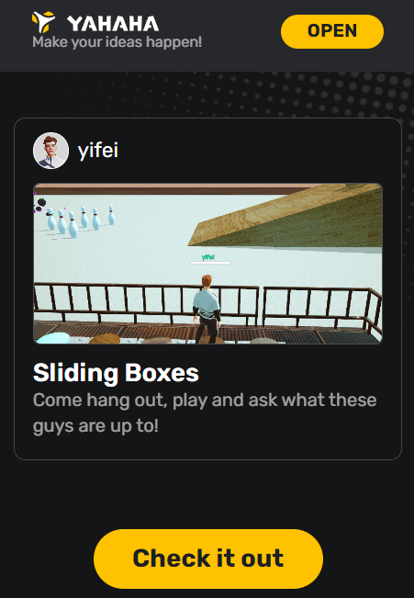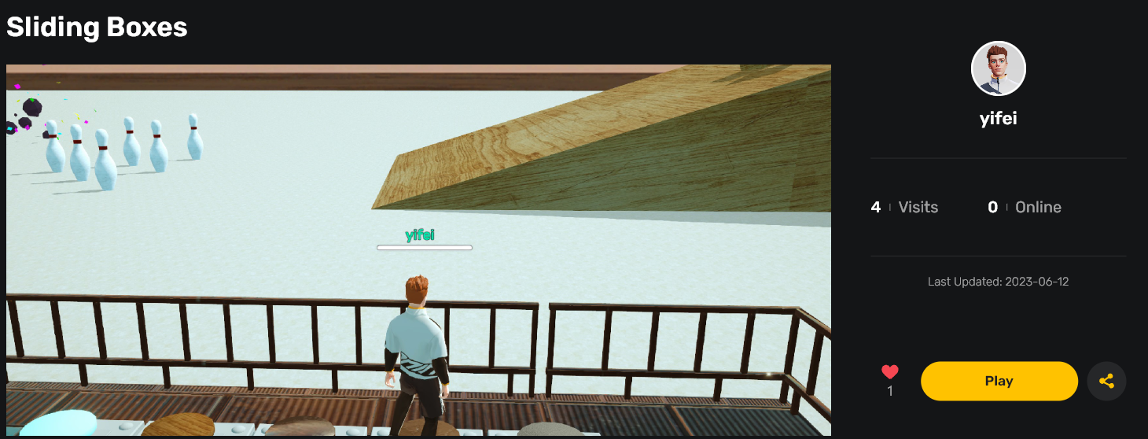

*Game Overview: This game aims to topple all the pins by strategically releasing blocks. Through gameplay, users will observe how different materials exhibit varying levels of frictional force.*

*By pressing the red button, you can alter the plane’s/slope's composition and observe how various material combinations affect the amount of frictional force experienced.*

*The buttons represent - Ice, Metal, Wood, Mud, and Rubber. All the materials possess identical densities except for variations in friction and bounciness. When pressing these buttons, a box with the respective material will drop on the inclined plane.*

*Controls*

*Arrow keys: To move around*

*Mouse: To look around*

*Step on the buttons: To press the buttons*

**

* *Fix the material of the plane to* ***ice*** *using the red button.*
* *Start by demonstrating the activity with one material, for example, an ice box.*
* *Repeat multiple times for one material if required.*
* *As you engage students in conversations and discussions about the game, repeat the process for each material as needed.*